Jiang Qing

Jiang Qing (1913-1991) was born as Li Yunhe in Zhucheng, Shandong Province. As Lan Ping, she became a moderately successful actress in Shanghai in the years 1934-1937. Her close friend—some say secret lover—Kang Sheng introduced her to Mao Zedong in Yan'an. Despite the fact that Mao was still married at the time to He Zizhen, she became his wife in 1939. The Party leadership supported He, and stongly objected to the marriage. Eventually, a compromise was found in the condition that Jiang would restrict herself to the role of housewife and would refrain from playing any role in politics. In the early 1960s, however, she sided with Lin Biao, and both made a bid for power.
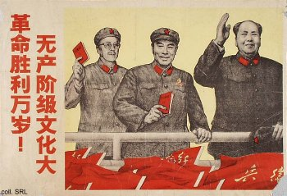 | 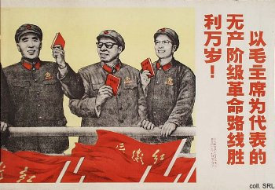
In the opening years of the Cultural Revolution (1966-1976), Jiang merely dominated the Chinese arts, in particular through her attempts to reform the Beijing Opera through her 'model operas' (yangbanxi). Later, she played an increasingly active political role in the movement, taking part in all important Party and government activities. She was supported by a radical coterie, dubbed the 'Gang of Four' by Mao himself. Although a prominent member of the Central Cultural Revolution Group and a major player in Chinese politics in the period 1966-1976, relatively few posters have been published which show her in action.
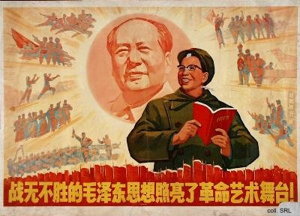
When Mao died in 1976, Jiang lost the support and major source of justification for her political activities. Hua Guofeng arrested her and the other members of the Gang of Four. I personally always thought that the poster below, made in 1976 and published a year later, was an allegorical way of showing the defeat of Jiang. Monkey (Sun Wukong), the hero of the popular Ming-dynasty novel Journey to the West, stood for the Chinese people, and the White Bone Demon, a devil of the first order, was Jiang Qing. However, when I proposed this theory to veteran designers Ha Qiongwen and Qian Daxin (formerly of the Shanghai People's Arts Publishing House), they were very amused, but insisted this was not the case.
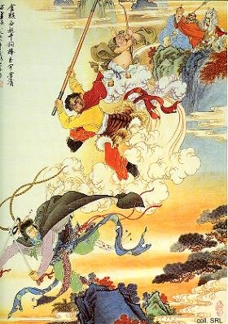
In January 1981, Jiang was sentenced to death with a two-year reprieve and permanent deprivation of her political rights. The sentence was commuted to life imprisonment in January 1983. Suffering from throat cancer, she was released on bail for medical treatment in early May 1991. Ten days after her release, she allegedly committed suicide.
Sources:
A Great Trial in Chinese History—The Trial of the Lin Biao and Jiang Qing Counter-Revolutionary Cliques, Nov. 1980-Jan. 1981 (Peking: New World Press, 1981)
David Apter & Tony Saich, Revolutionary Discourse in Mao's Republic (Cambridge: Harvard University Press 1994)
Wolfgang Bartke, Who was Who in the People's Republic of China (München: K.G. Sauer, 1997)
Wolfgang Bartke, Biographical Dictionary and Analysis of China's Party Leadership 1922-1988 (München: K.G. Sauer, 1990)
John Byron and Robert Pack, The Claws of the Dragon (New York: Simon & Schuster, 1992)
Chung Hua-min and Arthur C. Miller, Madam Mao: A Profile of Chiang Ching (Hong Kong: Union Research Institute, 1968)
Dachang Cong, When Heroes Pass Away—The Invention of a Chinese Communist Pantheon (Lanham MD, etc.: University Press of America, 1997)
Li Zhisui, The Private Life of Chairman Mao—The Memoirs of Mao's Personal Physician (London, etc.: Random House, 1996)
Roderick MacFarquhar, The Origins of the Cultural Revolution, Volume III: The Coming of the Cataclysm (Columbia University Press 1999)
Ross Terrill, Madame Mao—The White-Boned Demon (Toronto, etc.: Bantam Books, 1984)
Roxane Witke, Comrade Chiang Ch'ing (London: Weidenfeld and Nicolson, 1977)
Yan Jiaqi & Gao Gao (translated & edited by D.W.Y. Kwok), Turbulent Decade—A History of the Cultural Revolution (Honolulu: University of Hawai'i Press, 1996)
Yang Kelin (ed.),Wenhua dageming bowuguan [Museum of the Cultural Revolution] (Hong Kong: Dongfang chubanshe youxian gongsi, Tiandi tushu youxian gongsi, 1995) [in Chinese]

