Regulations for pupils, 2000

Behavioral indications for school children continued to be published in the year 2000. The set below shows all the characteristics of more sophisticated poster production: bright colors, high gloss finish, thick, good-quality paper. The rules themselves have not changed much. More interesting, however, are the illustrations. In both posters, a cartoon style is used that is clearly inspired by, if not copied from, the Japanese cartoons that most Chinese children now can see on television. As a result, the figures in the images have wide, round eyes, and look distinctly Western.
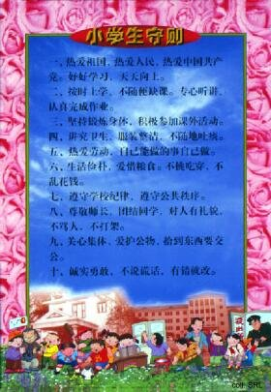 | 