Regulations for Primary School Pupils

The use of photographs in this series from 1995 makes it probably the most effective of all educational materials published to inculcate the values of the elusive concept of socialist spiritual civilization.
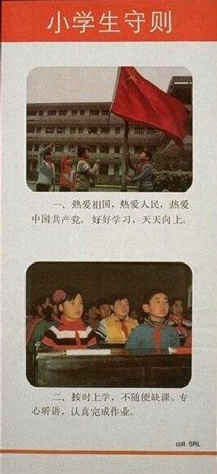 | 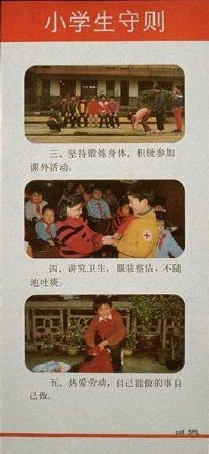

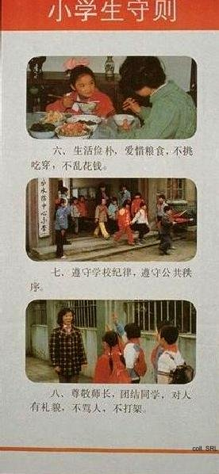 | 