Patriotic educational series, 1996

The renewed emphasis given to the formation of Socialist Spiritual Civilization in 1996 led to a flurry in the production of materials to be used in primary and middle schools. Below is another series.
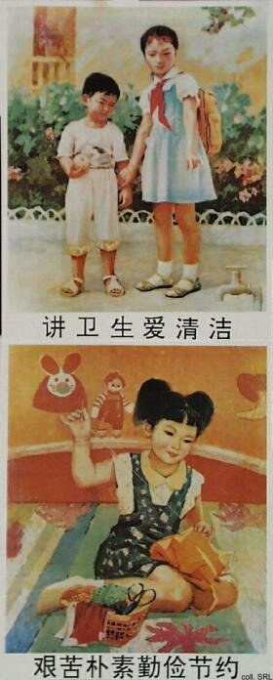 | 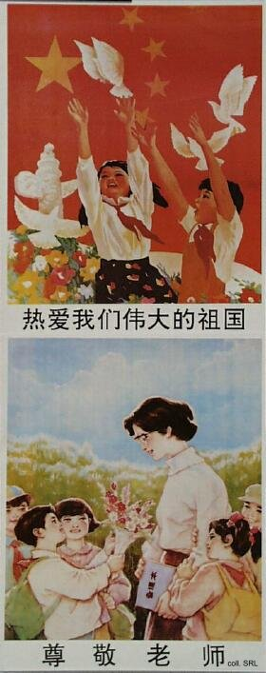

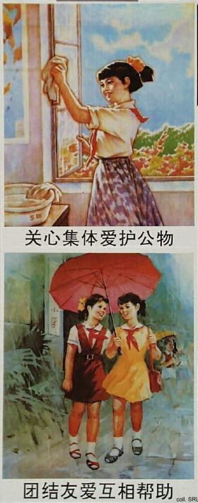 | 