Educational Series

This series of educational posters, published ca. 1994, seems to have even less propaganda contents than the Behavioral Standard Series of 1987. Note, however, the image of the wheelchair, a rarity in posters, and the use of sci-fi imagery.
The series is completed with posters of the 'Lei Fengs' of the 1980s and 1990s: the eminently emulatable youngsters Lai Ning, Lei Feng, Zhang Haidi and Zhang Hua. Two sheets with stirring sentences in Jiang Zemin's calligraphy round the series off.
 | 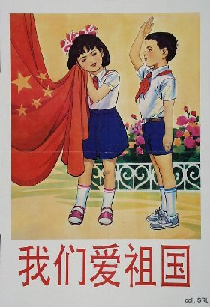

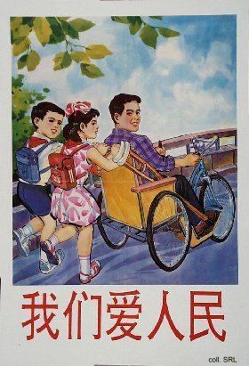 | 

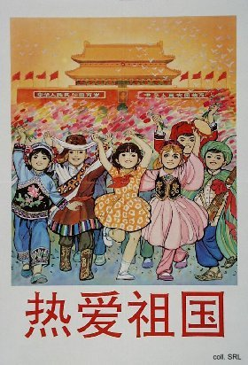 | 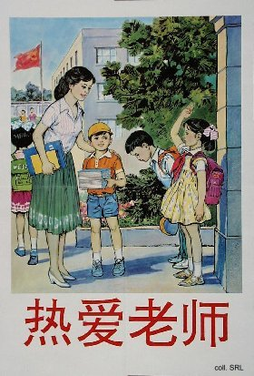

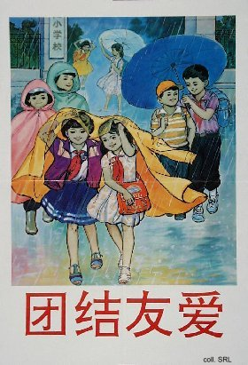 | 