The "Amazing" series, 1996

The four-part "Amazing" educational propaganda series (1996) was designed and produced in accordance with the CCP Propaganda Department's Outline to Implement Patriotic Education. The materials are intended for use in primary and middle schools.
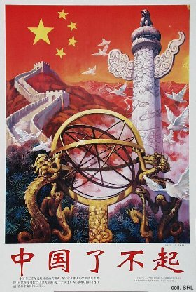 | 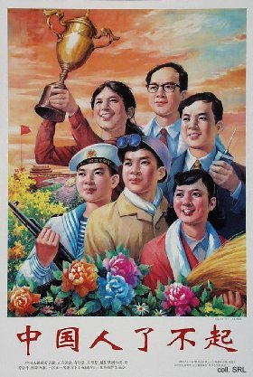

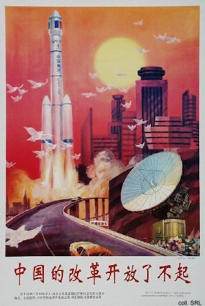 | 