Taiwan—Liberation

Over the past five decades, the People's Liberation Army has worked towards bringing Taiwan back into the fold. When the mainland was liberated in 1949, plans existed to invade Taiwan as well. Although the population was prepared for military action, the plans came to naught.
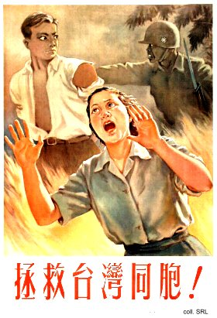 | 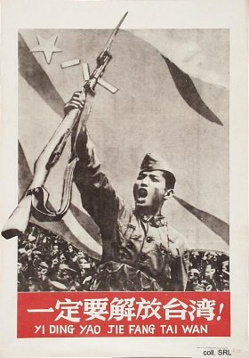
During the Taiwan Strait crisis of 1954-1955, and again in 1958, the Army bombarded the offshore islands of Quemoy (Jinmen) and Matzu (Mazu). This was designed as an initial stage of a renewed bid for taking the island.
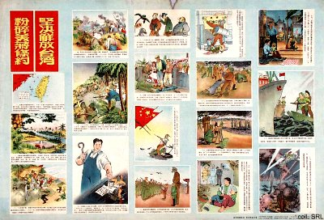
As can be seen in the poster below, copies of the Quotations of Mao Zedong, sealed in little plastic bags, were set overboard during the Cultural Revolution (1966-1976). This propaganda offensive was clearly intended to win the hearts and minds of the Taiwanese.
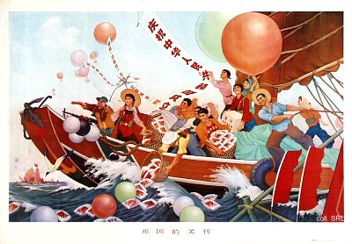
In the 1980s, the live ammunition used in bombarding the island was traded in for shells filled with propaganda materials, which the Taiwanese reciprocated in kind. In 1995-1996, the PLA was involved in naval and missile exercises off the coast of Taiwan in an attempt to influence the first presidential elections then taking place in Taiwan. This did not prevent the Taiwanese to vote for KMT-leader Lee Teng-hui, the candidate the PRC opposed the most. The resolution of the Taiwan issue has been high on the agenda of the successive generations of military and civilian PRC-leaders, including Hua Guofeng.
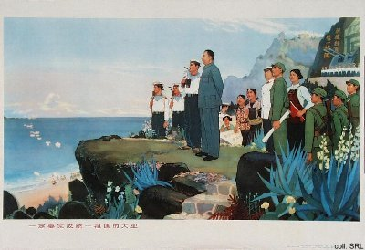
When Chen Shui-bian, the leader of the Democratic People's Party, in which the KMT-opposition has been united, was elected as president in 2000, tensions in the Taiwan Straits flared up again.

