Reunifications

Deng Xiaoping's formulation of the 'One Country, Two Systems'-paradigm has laid the theoretical foundation for China's resumption of sovereignty over a number of territories that had been under foreign rule due to historical developments. According to the paradigm, there is one country (China), but within this country, multiple social and/or economic systems can and will exist for a given period of time in certain areas, next to and in harmony with the social and economic systems prevailing in China.
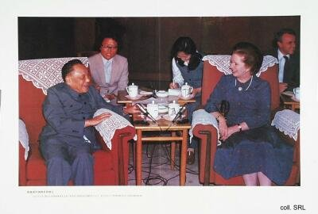
In the case of Hong Kong, where the theory was first tested in practice, this resulted in agreement over a high degree of autonomy under which Hong Kong's social and economic system would continue to exist for a period of (at least) fifty years, even though the territory had become a Special Administrative Region of China as of 1 July 1997. In other words, decisions regarding foreign policy, security matters, certain legal procedures, etc., fell within the authority of Peking. A similar agreement was put into place for Macao, which reverted to Chinese sovereignty on 20 December 1999. In the eyes of the Chinese leadership, Deng's paradigm already has proven to be an excellent vehicle to bring about the future reunification with Taiwan. Jiang Zemin in particular sees such a reunification as an eminent opportunity to guarantee him a lasting place in history. The Taiwanese leaders, however, have a different opinion on this matter......

