Macao

The Macao Handover, which took place on 20 December 1999, was marked with less spectacular media attention and speculation about economic consequences and the imminent trampling of human rights than had been the case with the Hong Kong Handover in 1997. All in all, the return of sovereignty over Aomen, as the territory is called in Mandarin, was a much more subdued affair. The Chinese government did publish an impressive series of posters to commemorate this historic occasion.
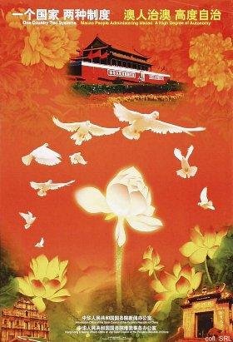 | 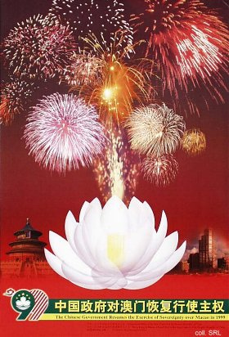

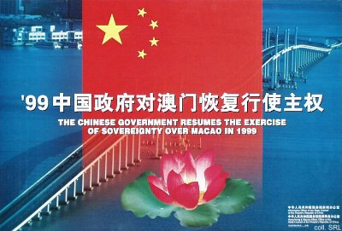
On the other hand, more generic looking posters, such as the one shown below, were also produced.
