Population Policy

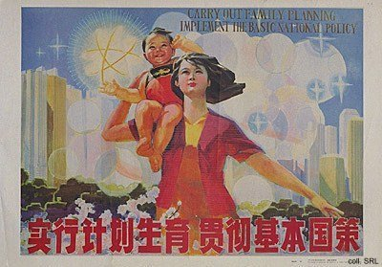
Propaganda posters were widely employed in the 'one child'-campaign, which started in 1979 in an attempt to deal with the staggering increase of the population in the 1960s and 1970s and to curb the projected problematic growth in the future. This campaign went much further than the "late, spaced and few"-campaign that had been started in the early 1970s.
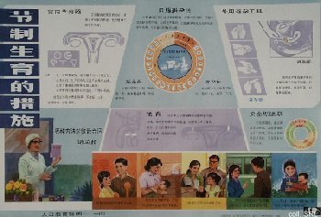 | 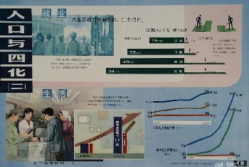

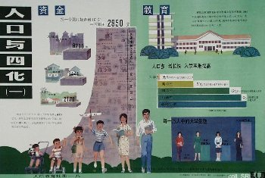
'Posters popularizing the science of family planning' explained the mechanism of human reproduction, and the various available methods to limit one's offspring to a single child. They were produced for use in glass display cases erected in streets or for community rooms. Such educational posters included explanations about what a woman feels when she is pregnant, the use of condoms, etc.
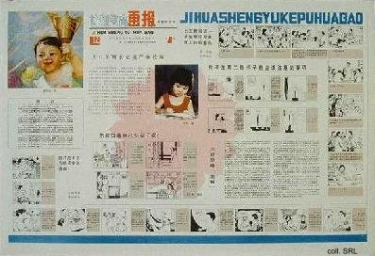
In order to communicate the message that the offspring of a couple from now on should be limited to one child, traditional visual elements from nianhua (New Year prints) were used that were known to appeal to the people. The pictures featuring chubby baby boys and gold carp attracted the population of both rural and urban areas, whether or not they contained slogans to the effect that 'one is better.'
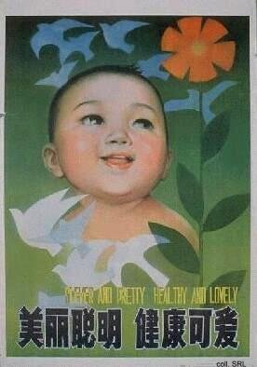 | 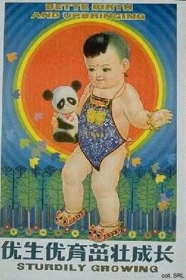
In other posters. young people were called upon to marry later and to conceive later and less children, as illustrated by the two posters below, which includes a calendar for 1988.
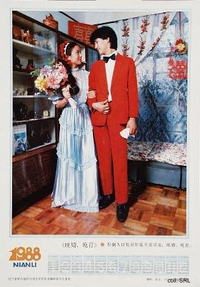 | 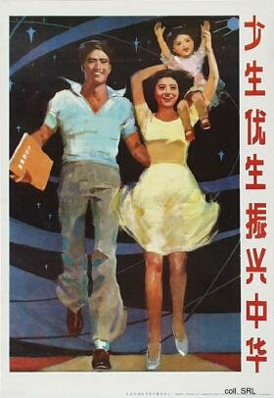
Western bridal clothes were not the only indication that the people's livelihood was improving. Various elements of economic development started to creep into the more traditional poster-design. This started with highrise buildings in the background, and ended with the use of Western imagery: space ships, atomic symbols, even remote controls. The visual element that many of these posters have in common is the dove; this bird is not presented as the traditional emblem of long life, but as the internationally accepted icon of peace.
