Woman Warriors

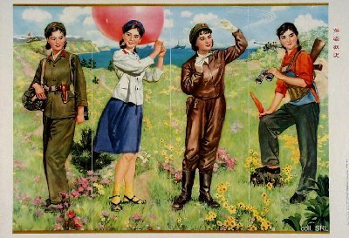
As a revolutionary organization, the PLA has been an equal opportunity employer avant la lettre: women were given the opportunity to sign up.
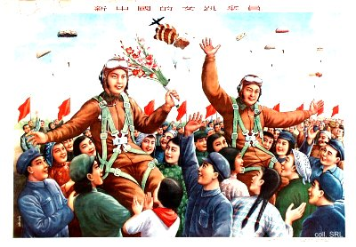
For many young women, in particular for those of worker or peasant background, joining the PLA was considered an excellent opportunity to break out of the traditional bonds of oppression and discrimination which still held most of them captive.
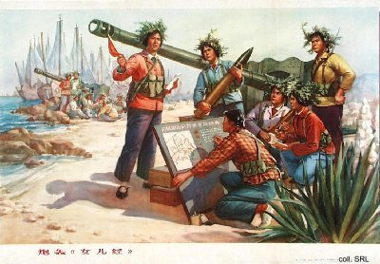
Joining the PLA almost automatically led to acceptance by the Party, and this in turn opened various career prospects that otherwise would have remained inaccessible to them. The army enabled young women to acquire non-traditional skills that were useful in civilian life; demobilized soldiers were honored in their villages and, very important, had good access to the local bureaucracy.
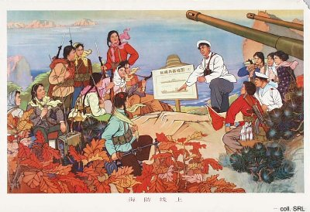
Many women carved out a carreer in the PLA. Others became cadres in their places of origin, thereby providing status for their families, although they still had to face the problem of the traditional male chauvinism that continued to exist. Even nowadays, with a much richer choice in employment opportunities, an Army carreer is seen as worthwhile by many.
