People's Liberation Army

The predecessor of the People's Liberation Army (PLA), the Red Army, came into being with the Nanchang Uprising on 1 August 1927. On the basis of Mao Zedong's theory of 'people's war', this revolutionary army was to have both a political and social role. These roles consisted of doing propaganda among the masses, organizing the masses, arming the masses, helping them to establish revolutionary political power and setting up Party organizations. While doing this, the Party at all times was to maintain control over the army.
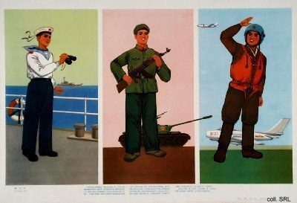
The fact that most Chinese political leaders (Mao Zedong, Deng Xiaoping, Zhu De, Ye Jianying, Lin Biao) had military carreers reflects this dual role of the PLA. The participation of the political elite in military affairs also meant that there was little emphasis on formal training of officers. In the PLA, being 'red' was always considered better than being 'expert'. The political character of the PLA also contributed to the formation of a mystique of the army as a disciplined, politically conscious force that was closely engaged with the task of rebuilding the nation.
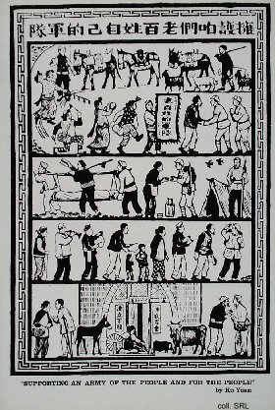 | 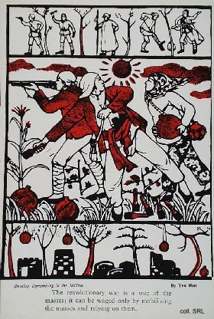
Traditionally, the military had a very low social status in China, aside from a folklore built around romantic soldiers and military heroes of virtue. "Good iron is not made into nails, a good man does not become a soldier", as the popular saying goes. This image changed dramatically during the revolutionary war period; joining the PLA became an aspiration for many young people, in particular for those of worker or peasant background. Aside from patriotic motives, joining the PLA almost automatically led to acceptance by the Party, and this in turn opened various career prospects. The army enabled young people to acquire skills that were useful in civilian life; demobilized soldiers were honored in their villages and, very important, had good access to the local bureaucracy. Many became cadres themselves, thereby providing status for their families. Others played a major role in national politics, in particular after 1969, when the PLA was called in to restore order after the Cultural Revolution had resulted in total chaos.
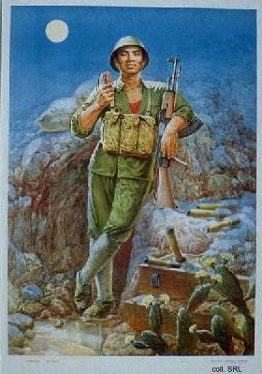 | 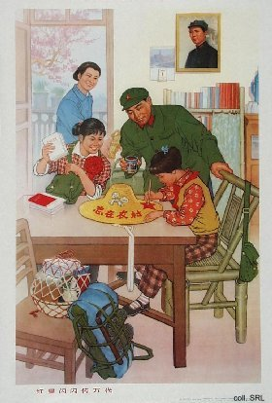
As a fighting force, the PLA has often been able to accomplish astonishing military feats in the face of adversity. Despite often inadquate armaments, the Army succeeded in defeating superior Nationalist forces during the civil war of 1946-1949, paving the way for the founding of the PRC. Although undereducated and underbudgeted, the PLA applied guerrilla tactics, emphasizing flexibility and a close integration with the people. Constant ideological training prepared the soldiers for hardship and sacrifice for the revolutionary cause.
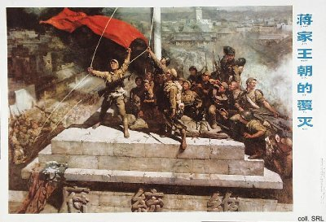
After the founding of the PRC, the PLA started to play a role in China's foreign policy by actively engaging in a number of conflicts. The Army fought the American troops in Korea in 1950-1953 and against India in 1963 (unresolved until the present day), it clashed with former ally the Soviet Union along the shared Northeastern border in 1969, battled with South-Vietnamese troops in the South China Sea in 1974, marched against Vietnam in 1979, and came into conflict with a number of countries over the Spratly Islands since the mid-1980s. The PLA supported North-Vietnam during the Vietnam War, and deployed advisers and troops against American forces in Southeast Asia.
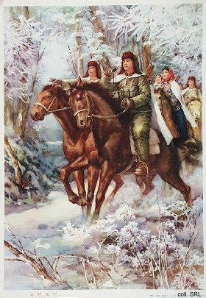 | 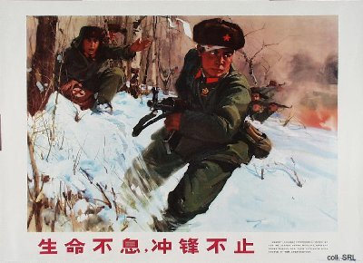
Over the past five decades, the PLA has worked towards bringing Taiwan back into the fold. During the Taiwan Strait crisis of 1954-1955, and again in 1958, the Army bombarded the offshore islands of Quemoy (Jinmen) and Matzu (Mazu). In the 1980s, live ammunition was traded in for shells filled with propaganda materials, which the Taiwanese reciprocated in kind. In 1995-1996, the PLA was involved in naval and missile exercises off the coast of Taiwan in an attempt to influence the presidential elections then taking place in Taiwan. The resolution of the Taiwan issue has been high on the agenda of the successive generations of military and civilian PRC-leaders, including Hua Guofeng.
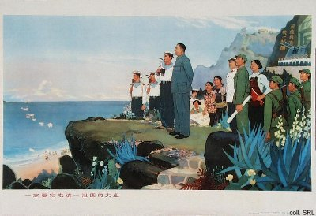
Despite these activities, the PLA has always devoted its best energies to internal affairs. In the military sense, it pacified the country in the early 1950s, defeating Nationalist remnant troops and local militias. The Army occupied Hainan Island, participated in political campaigns to wipe out the landlord class and suppress counter-revolutionaries, and occupied Tibet. During the Great Leap Forward, the Army was used to prevent peasants from fleeing rural areas stricken by famine, and in the early 1960s, the military took over many government and State-functions.
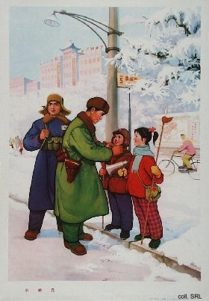 | 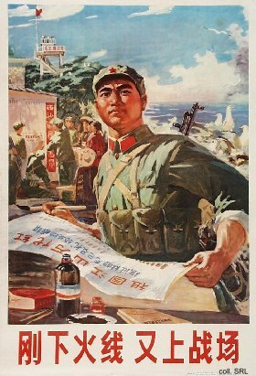
Aside from its military and political functions, the PLA has always been used as an economic resource as well. During the revolutionary war, wherever soldiers went, they participated in food production to supplement reserves in the area and lighten the burden on the local population. After the founding of the PRC, the PLA's domestic economic role was enlarged. The huge number of demobilized soldiers, while retaining their military organization, was employed in civilian production, both in agriculture and in industry. The military moreover was involved in setting up state farms and massive land reclamation projects, in particular in the Northeast.
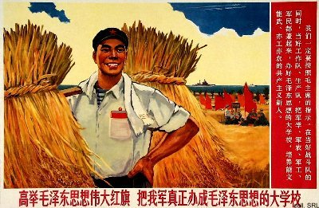
In the era of modernization, the role and position of the PLA in Chinese society has changed enormously. An Army career is no longer considered as one of the few available opportunities for social mobility: people rather try their luck as independent entrepreneurs. This has created problems for PLA-recruitment policies. On the other hand, the professionalization of the PLA-organization over the past two decades, now stressing arms over men, has made the Army rather reluctant to take in inskilled recruits from the countryside, preferring (urban) university graduates instead. Due to a reduction of the ranks (some 1.5-2 million in the last 15 years), a number of traditional PLA-functions has shifted to other organizations, in particular the People's Armed Police. This latter organization became the first line of defense against civil unrest. The PAP, backed when necessary by the PLA, has taken on much of the grass-roots work; recently, it has been involved in combatting the yearly floods that wreak havoc in the countryside.
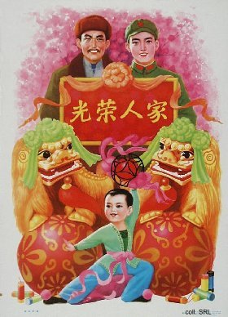 | 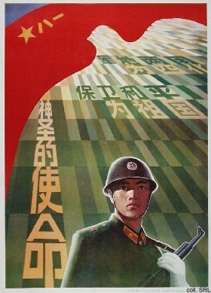

Sources:
Flemming Christiansen & Shirin Rai, Chinese Politics and Society—An Introduction (London etc.: Prentice Hall 1996)
Andrew J. Nathan & Robert S. Ross, The Great Wall and the Empty Fortress—China's Search for Security (New York etc.: W.W. Norton & Company 1997)

