Beijing Olympics 2008

On 13 July 2001, the International Olympic Committee voted for Beijing to host the Olympics in 2008. This decision ended a period of intense lobbying, in which at one point the Chinese government stated that hosting the Olympics constituted a human right for the Chinese people. China's candidacy met with fierce opposition from various quarters. The country's human rights record in particular was mentioned most often as a reason for not honoring Beijing. In 1993, human rights, and the repression of the student demonstrations in 1989, had been reasons for China's loss to Sidney to organize the 2000 Olympics.
 | 
Millions of yuan and dollars were invested in the publicity campaign. Complete sections were sponsored in major news papers, including the International Herald Tribune, in order to sway public opinion. The posters shown here are produced for domestic consumption.
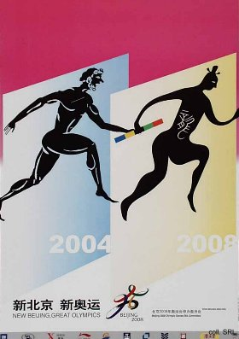 | 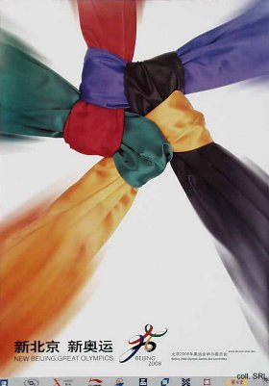
With the slogan "New Beijing--Great Olympics", the government now is faced with more capital outlays: US$12 bn. is earmarked for a huge environmental cleanup, which will inlcude the closing down or relocation of polluting factories. Another US$22 bn. is set aside for the construction of Olympic stadiums and and transport improvements. According to officials, construction will include work on Tian'anmen, where beach volleyball and triathlon races are scheduled.

Click here for the official New Beijing, New Olympics-website.

