New Year Prints (and chubby babies)

The New Year picture (nianhua) was the most important influence on the propaganda posters produced by the Chinese Communist Party. Employing various elements of folk art and symbolism, these pictures catered to the tastes and beliefs in the countryside, expressing wishes for happiness and good luck. According to the Chinese nianhua specialist Wang Shucun, "During the New Year festival, more than 20 varieties of New Year prints would be stuck on the front gates, doors onto the courtyard, walls of a room, besides a room's windows, or on the water vat, rice cabinet, granary, or livestock fold. Colourful and floral prints would be everywhere in the house to express the hopes and joy of the festival."
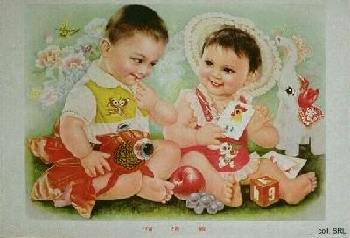
Nianhua derived from 'paper gods' and other forms of utilitarian-magic art and made use of symbols that were traditionally and conventionally seen as auspicious, including those for long life, a government career, and wealth. This contributed to their popularity among the people. Often, they featured mythological personages like the Kitchen God, the Door God and the God of Longevity; this turned them into magical charms to drive away bad luck.
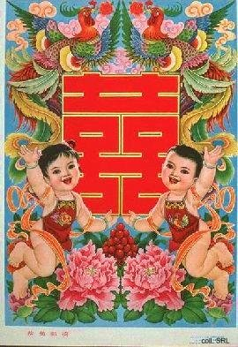 | 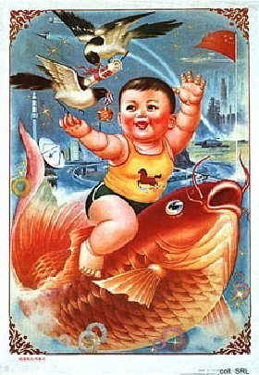
When the CCP appropriated New Year prints for propagandistic purposes in the 1940s, artistic and aesthetic forms were selected that the people had grown accustomed to, filled with new, revolutionary content. But the revolutionary artists looked down on these old forms of popular culture; they were more dedicated to the cosmopolitanism of the cities. They considered traditional art forms to be too intimately connected with the elements of 'feudal,' Confucian superstition.
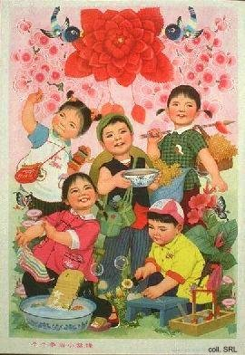 | 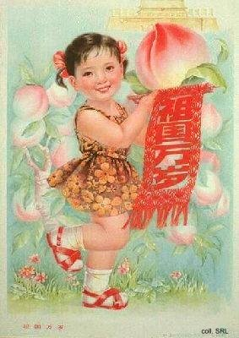
The nianhua produced by the Party were, on the one hand, much too 'Chinese' and vulgar to please intellectuals and the urbanites who considered themselves to be more sophisticated. The masses, on the other hand, found them too Westernized and over-simplified to be of great interest for them. 'New' nianhua, then, only existed because of the Party, for political reasons. They only replaced traditional nianhua because the CCP succeeded in shutting the latter out by prohibiting their production and distribution. This explains why propaganda posters could be seen in many individual homes in the first decades of CCP-rule.
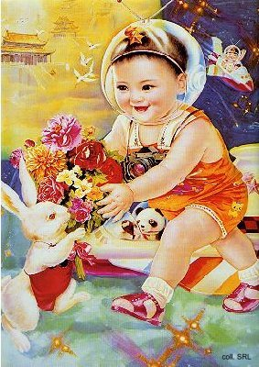 | 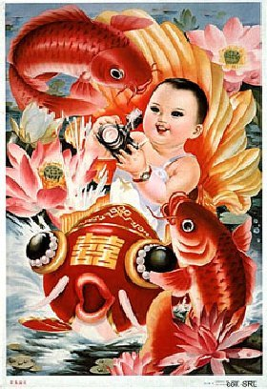
It also explains why other visual materials that contained more traditionally significant symbolic contents, started to replace them as soon as they became available on the free markets in rural and urban areas in the 1980s.
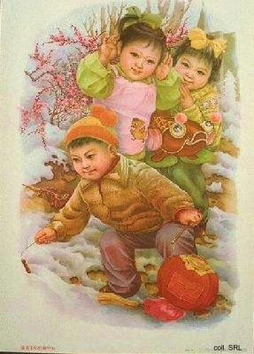 | 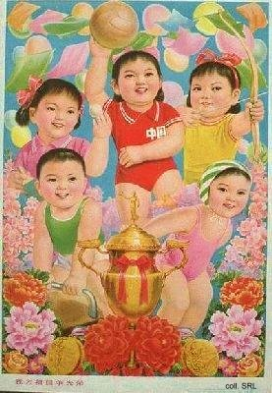
What has always been, and has remained, popular are New Year prints devoted to children. The chubby baby boys (pang wawa), particularly those holding carps, which denotes male offspring and abundance, continue to encapsulate traditional ideals of wealth, happiness, longevity, and others. Although babies are still depicted with protective charms around their necks, clutching peaches of immortality, surrounded by magpies and mandarin ducks, they increasingly are portrayed as girls.
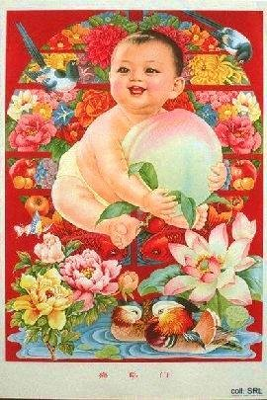 | 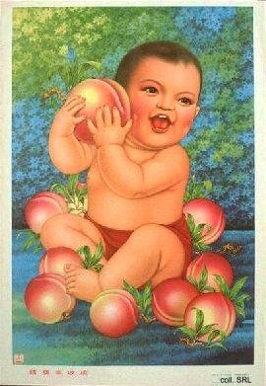
Moreover, various visual elements of economic development have started to creep into the more traditional poster-design. This starts with highrise buildings in the background and soon turns to space ships and atomic symbols, crowding out traditional imagery more and more as time progresses. The visual element that these posters have in common is the dove; this bird is not presented as the traditional emblem of long life, but as the internationally accepted icon of peace.
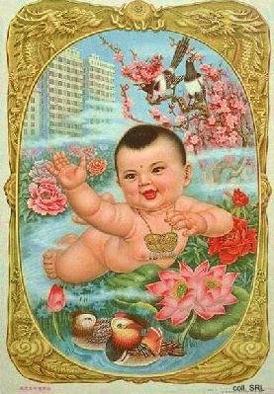 | 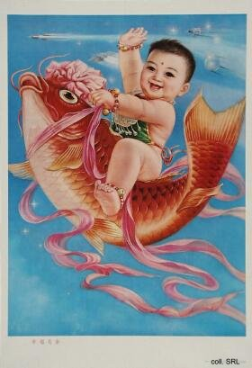
In the 1990s, non-political nianhua in the traditional style are once again produced. The San Xing, the gods of happiness (Tian Guan, the 'Heavenly Official'), emolument (represented by Zhou Wen Wang) and longevity (in the archetypical form of the bald-headed Shou Gong), looking young and vigorous, holding their various symbols of rank, dominate the top half of the picture. The He-He twins, symbolizing good fortune, marital harmony and wealth, hold up a copper pot adorned with the characters facai, becoming rich. The attention of the spectator is drawn to the contents of this copper pot, which is located conveniently in the centre of the print: stacks of 50 and 100 yuan RMB bills, and a sizable stack of American $100 bills.
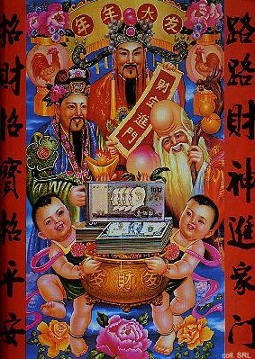
The poster 'Bette[r] birth and upbringing, sturdily growing', produced after 1986 to support the 'one child'-campaign, uses various visual elements that correspond with traditional concepts and symbolism surrounding childbirth employed in nianhua, although it does so in a rather clumsy way. These elements include the little apron that the baby boy wears, the 'tiger slippers,' as well as the amulets around his neck and his left wrist. He moreover has a red spot painted on his forehead as protection against disease. However, he is not smiling. Nor is he chubby, as babies are supposed to be, and instead of holding a fish (yu, a homophone of the word yu denoting abundance), he holds a rather skinny toy-panda. Other auspicious symbolism is missing as well; worst of all, the dominant colour is blue, a hue considered to be ambiguous, and the auspicious red is almost completely absent. It is hard to say how such a poster contributed to popular conformity with the message.
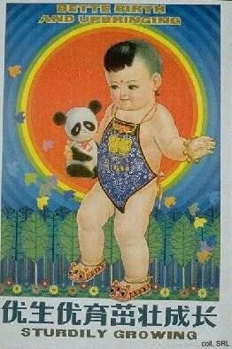 | 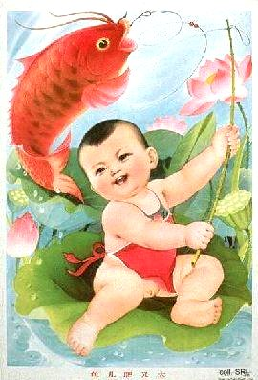
The difference between this print and an earlier one, 'The fish is fat and big' (above right), is striking. Most remarkable is the exuberance and happiness emanating from the poster. This in itself gives the image the quality of bringing joy that nianhua ought to have. The baby, in full frontal nudity, may lack a red spot on his forehead, and he has no amulets for magical protection, but he is happy. Moreover, he has succeeded in hooking the fish of abundance in a pool of lotus flowers [lian], meaning "May you have abundance [yu] year in and year out [lian]."

