National Minorities

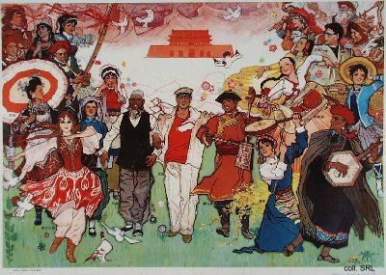
China is a multi-ethnic state. Aside from the Han Chinese, which account for 92.5% of the population (according to the 1990 census), there are 56 officially recognized "national minorities", numbering some 91 million people. These minorities inhabit some 60% of Chinese territory. The largest minorities are the Zhuang (in Guangxi Zhuang Autonomous Region, 15 million); the Manzu, or Manchu (in Northeast China, 9.8 million); Moslems, or Hui (all over China, 8.6 million); Uygur, or Weiwu'er (in Xinjiang Province, 7.2 million); Tujia (Hunan Province, 5.7 million); Mongolians, or Meng (Inner Mongolia, 4.8 million); and Tibetans, or Zang (in Tibet, Qinghai and Sichuan, 4.6 million). The smallest national minorities number only a few hundred members, for example the Ewenki. Many other different ethnic groups (as many as 350) seek official recognition, and at least 15 of them are reported to be officially considered for such recognition.
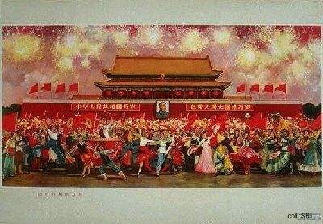
It is important for an ethnic group to be officially recognized as a national minority. Minority peoples are given special treatment, including a license of moral, cultural, religious and social liberties which the state does not wish to grant to the majority of the population. These liberties include a family planning policy which does not restrict the number of children; the right to retain certain marriage patterns and traditions of conducting one's sexual life; and the right to engage in various forms of religious practices which are otherwise considered "superstitious". On the political level, being a minority may lead to a level of limited autonomy that leaves room for local decisions on education, finances, culture and religion. It is also important for the state to officially recognize a national minority. It has set up an apparatus for registering and administrating ethnic differences, allotting different rights to different ethnic groups. This enables selective social control and formal structures for political inclusion or cooptation of groups which otherwise might alienate themselves from the system.
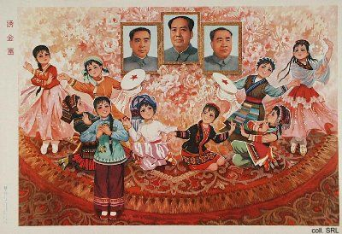
The cooptation of minority interests has been an important factor in forging national unity, in merging all 57 national individual minorities into one Chinese nation. Another element has been the presentation of the best and most pliable elements of nationality culture in terms of this unity. In the media, national dances, music and songs are woven together in a mixture which implies unity while at the same time emphasizing the individual characteristics of each nationality.
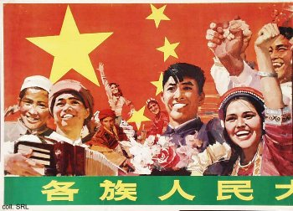 | 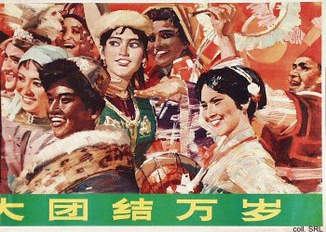
Although it can be said that these elements have saved certain minority practices from extinction, they at the same time have had a stiffling effect on the development of these peoples. The 'noble savages' in their colorful national costumes, fellow countrymen yet so alien, living in their traditional dwellings and compounds, engaging in traditional songs and dances, have become important components of a thriving tourist industry that caters to both foreign and Chinese visitors. Sadly enough, the minorities themselves usually are not sharing in the profits.
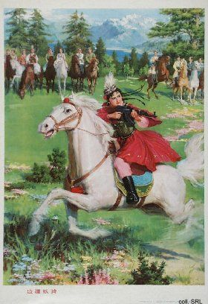 | 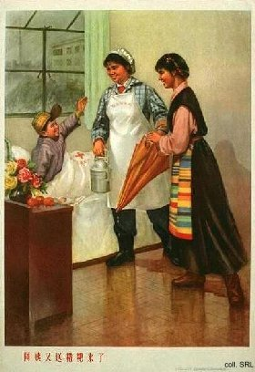
Despite the formal cooptation of minorities, despite the forging of a national unity, the actual integration of these diverse ethnic groupings remains a problem. This can be deduced from the regular exhortations in the official media to combat "great-Han chauvinism". Many Han Chinese see the minority peoples as wayward children, as backward communities, and freely discriminate against them. The Hans feel that the minorities are pampered, difficult to please, and ungrateful. The fact that the minorities had been subjected to less severe population policy restrictions in particular has created great resentment in the recent past.
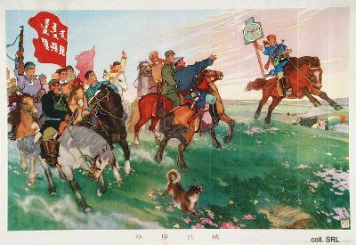
That the state felt the need to instruct the minorities is quite obvious from the propaganda posters produced in the first three decades of the PRC. They all show happy minorities enjoying the fruits of socialism, but guided by the Han. Another indication of the ethnic unity that existed was provided by the posters dedicated to mass scenes extolling the virtues of the PRC or of Mao. They usually featured token Tibetans, Miao, Dai, Khazaks and others minorities in national dress, acting as icons for the ethnic diversity of China.
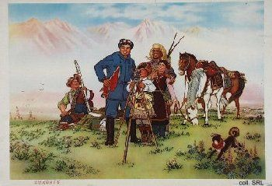 | 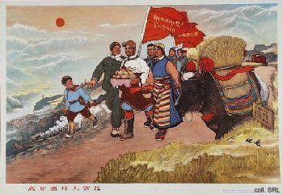
Compared with the past, the number of propaganda posters in which the national minorities played a role decreased spectacularly in the 1980s. There seemed to be no need any more to represent minorities being treated in hospital by Han nurses, or on fact-finding tours in factories, where they were shown around by fraternal Han workers, as was the case during the Cultural Revolution. While the late 1970s witnessed the production of a number of posters depicting the minorities' joy with concrete fruits of development, such as wireless radios and electricity, this disappeared in the 1980s. It could be an indication of the leadership's worries about giving rise to unrealistic expectations among the minorities.
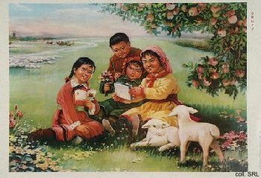 | 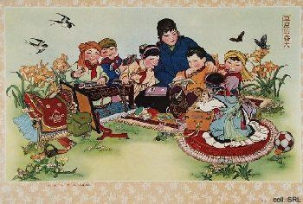
The only examples in which artists continued to use representatives of the minorities, in their colourful garb, were those in which the founding fathers of the CCP, such as Mao, Zhou Enlai, Liu Shaoqi and Zhu De, were depicted, in order to perpetuate the image of one happy extended family of peoples. In line with the more urban orientation that propaganda took in the 1980s, the minorities' propaganda appeal has clearly diminished.
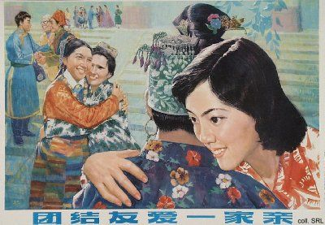

Sources:
Flemming Christiansen & Shirin Rai, Chinese Politics and Society—An Introduction (London etc.: Prentice Hall 1996)
Frank Dikoetter, "Reading the Body: Genetic Knowledge and Social Marginalization in the People's Republic of China", China Information, vol. 13, no. 2/3 (Autumn/Winter 1998-1999), pp. 1-13

