Mao in Silk

At the height of the cult surrounding him, Mao's image was reproduced on practically every medium imaginable. Porcelain, ivory, gypsum, rock, wood, leather, paper (both as papercut and as poster), embroidery, scrap metal, and even silk fabric bore images of the Chairman.
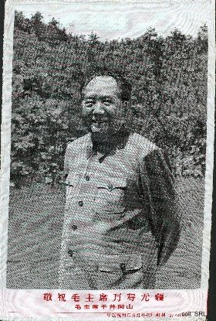 | 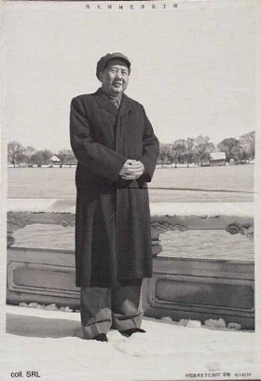
These silks reproduced well-known images of Mao and Party history. They were manufactured by the Hangzhou "East is Red" Silk Factory and could be framed or mounted as scrolls.
