Mao Pop

Under the political clampdown after the Tian'anmen Incident (1989), many avant-garde artists felt hampered to express their socially critical side. Painting with a cynical attitude, they recycled images from propaganda posters and from the Cultural Revolution in their works. Mao Zedong became a frequent and favored subject of what came to be named Political Pop, or Mao Pop. The phenomenon echoed the sudden enthusiasm for Mao relics and Cultural Revolution songs (set to a discobeat) in Chinese society.
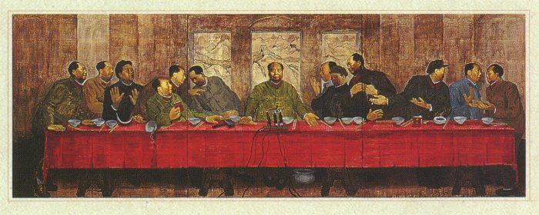
The image above, The Last Banquet (laser prints, pages of the Red Book and acrylic on canvas, 1989), is one of my favorite examples of Mao Pop. It is not a poster, and it is not in my possession. The artist, Zhang Hongtu, has graciously given me permission to use it in these pages. Many more samples of Hongtu's art (both Mao Pop, which includes the Mao Zedong acupuncture chart, and other works) can be found on his excellent webpage MoMao.
Sources:
Julia F. Andrews & Gao Minglu, "The avant-garde's challenge to official art", in Deborah S. Davis, Richard Kraus, Barry Naughton, and Elisabeth J. Perry (eds), Urban spaces in contemporary China—The potential for autonomy and community in post-Mao China (Cambridge, etc.: Cambridge University Press, 1995), pp. 221-278
Geremie Barmé, Shades of Mao—The Posthumous Cult of the Great Leader (Armonk, N.Y.: M.E. Sharpe 1996)
Alan Riding, "Chinese Artists Look Back", International Herald Tribune (28 September 1996)

