After Mao

When Mao Zedong died on 9 September 1976, the country was in shock. This was partly the result of the keenly felt loss of a semi-divine leader, but also caused by the enormous uncertainty about what the future held in stock for China and its people. The power struggle between Jiang Qing and the Gang of Four on the one hand, and Mao's designated successor Hua Guofeng on the other, which had been smoldering for some time, was about to be fought out in public. Some of this uncertainty is visible in the tenseness of the faces of the persons in the poster below. However, on 6 October 1976, within a month after Mao's death, Hua had the Gang of Four arrested. This bold move was supported by various old Party cadres and Army men, including Ye Jianying, Li Xiannian, Xu Xiangqian and Nie Rongzhen.
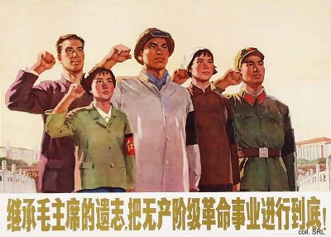
Two days after the arrest of the Gang, the highest organs of the party and the state decided that a Memorial Hall would be built as a permanent tribute to the founder of the People's Republic. On 24 November 1976, the foundation stone for the gigantic building, located to the south of the Monument to the People's Heroes on Tian'anmen Square, was put in place. The construction went on day and night, and the building was finished on 29 August 1977. On that same day, Mao's body, which had been embalmed and placed in a crystal sarcophagus, was moved to the Hall. On 9 September 1977, a ceremony was held to commemorate the anniversary of Mao's death and the completion of the Hall.
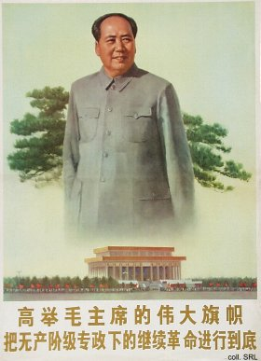
Although the Hall is open to the public, it tends to be closed for maintenance purposes for extended periods of time. It is unclear whether this maintenance is needed for the upkeep of the building, or for Mao's remains. Nonetheless, the Hall still draws large crowds of visitors, many of whom lay flowers at the foot of a marble statue of a sitting Mao, located in the northern entrance hall.
Sources:
Dachang Cong, When Heroes Pass Away—The Invention of a Chinese Communist Pantheon (Lanham MD, etc.: University Press of America, 1997)
Kwok-sing Li (editor) & Mary Lok (translator), A Glossary of Political Terms of the People's Republic of China (Hong Kong: The Chinese University Press 1995)
Li Zhisui, The Private Life of Chairman Mao—The Memoirs of Mao's Personal Physician (London, etc.: Random House 1996)

