Zhu De

Together with Mao Zedong, Zhu De (1886-1976) formed the backbone of the Chinese Revolution. In the 1930s and 1940s, the Chinese Communist Party was known in China as the "Mao - Zhu (rebel) forces". Born in a poor peasant family, Zhu was nonetheless able to attain the traditonal title of xiucai (budding talent), thereby qualifying for a rank in the Imperial civil administration. After studying at a military academy, Zhu joined the ranks of the revolutionaries at an early age by joining Sun Yatsen's Guomindang. In 1922, he went to Paris, and travelled on to Berlin, where he met Zhou Enlai and joined the German Branch of the CCP. From 1924 until his expulsion from Germany in 1926, Zhu studied at Goettingen University. After his return to China, he served as commander in various Army units.

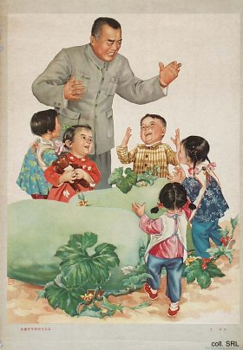 | 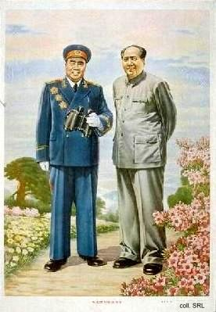
In 1927, he participated with Zhou Enlai, Li Lisan and other early CCP-leaders in the abortive Nanchang Uprising. After this failed, he led the remnants of his troops eventually to Jinggangshan, where he joined forces with Mao Zedong. There, the 4th Red Army was formed, with Zhu as commander and Mao as political commissar. In the Jiangxi Soviet, Zhu also started his carreer as a CCP-leader by joining the Central Committee. After the Long March and the arrival of the revolutionary forces in Yan'an, Zhu was made commander of the 8th Route Army. Subsequently, he became Commander-in-Chief of the People's Liberation Army in 1945.
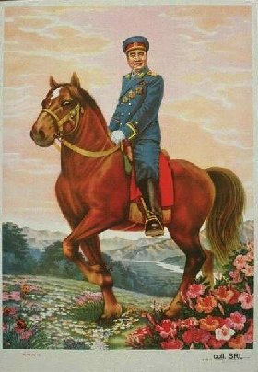 | 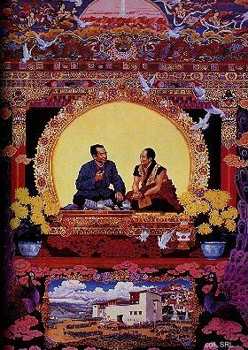
In 1955, Zhu was made a marshal of the PLA, together with such famous commanders as Ye Jianying, Peng Dehuai, He Long, Liu Bocheng and Lin Biao. Despite his immaculate carreer in the service of the revolution, Zhu was attacked by Red Guards during the Cultural Revolution (1966-1976) as a great warlord and an anti-Mao element.
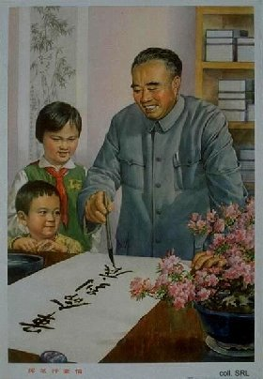

Sources:
Dachang Cong, When Heroes Pass Away—The Invention of a Chinese Communist Pantheon (Lanham MD, etc.: University Press of America, 1997)
Liao Yiwen (ed), Tian Lun [Family Love and Friendship) (Tianjin: Tianjin jiaoyu chubanshe, 1995)

