Zhao Ziyang

Zhao Ziyang (1919), former General Secretary of the Chinese Communist Party (CCP) and a protégé of Deng Xiaoping, was considered as one of the most reform-minded leaders in the 1980s. He joined the Party in 1938. In the 1950s, he was actively involved in the land reform campaigns in Guangdong Province. When Deng was persecuted as a "capitalist roader" during the Cultural Revolution (1966-1976), Zhao suffered a similar fate. After his rehabilitation in the early 1970s, he resumed his climb through the ranks. After a stint in Inner Mongolia, he returned to Guangdong. In 1973, he was elected as a member of the Central Committee. By 1976, he was transferred to Sichuan, Deng's native province.

By experimenting with "responsibility systems" in agriculture, Zhao became known as a reformer. After Deng's policy of the "Four Modernizations" was adopted in 1978, the rural reforms that followed were closely modelled on Zhao's experiments. In 1980, he was made Premier of the State Council, and strongly supported policies to increase the role of the market and to separate Party and State.

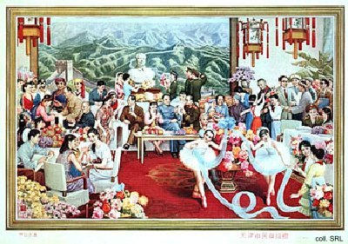
In 1987, he reluctantly agreed to replace Hu Yaobang as General Secretary of the CCP. This diminished his influence on the process of political and economic reforms. Amidst accusations of having tried to split the Party by supporting the student demonstrations on Tian'anmen, Zhao was purged in the summer of 1989 and given house arrest. Since then, he has been in political limbo, perfecting his golf game.

Although admired and even loved by the people, Zhao's reform agenda was feared by the more conservative Party elders. This may be one of the reasons that no posters featuring Zhao were published. A plan to publish a poster with Deng, Hu and Zhao, was quietly shelved in 1989. The poster shown, donated in 1986 to the civil administration of Tianjin, is one of the only ones known to show Zhao (standing towards the right, wearing glasses), Hu and Deng (both seated on the sofa). They are surrounded by a number of other leaders, including Chen Yun and Li Xiannian, and various models of the time, including Zhang Haidi.
Source:
Dachang Cong, When Heroes Pass Away—The Invention of a Chinese Communist Pantheon (Lanham MD, etc.: University Press of America, 1997)

