Song Qingling

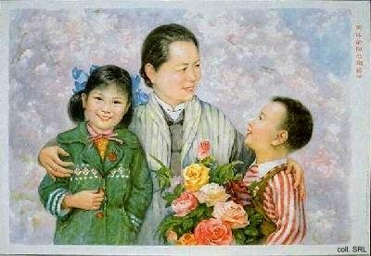
Song Qingling (also known as Mme Soong Qingling, 1890-1981) was born into a rich Christian family which played an important role in Chinese politics in the first half of the 20th century. Qingling and her sister Ailing studied at the Wesleyan College for Women in Macon, Georgia; her sister Meiling attended Wellesley College in Wellesley, Massachusetts. Qingling married Sun Yatsen in 1915, whereas Ailing married the banker and political figure H.H. Kung, and Meiling married Chiang Kaishek.
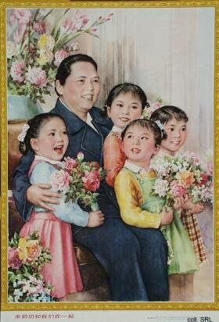
As the widow of Sun Yatsen, Song Qingling became an important member of the elite of the People's Republic of China, although she was only made a member of the Party one week before her death. She was present on the Tiananmen rostrum when Mao Zedong delivered his speech inaugurating the PRC in 1949.
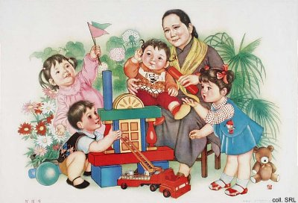
Although being one of the Vice-Chairpersons of the People's Republic, her influence in political matters was limited. Instead, she busied herself with various welfare activities, ranging from heading the Women's Federation to a number of committees involving (orphaned) children.
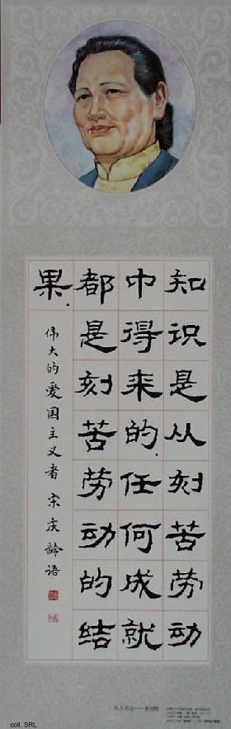

Sources:
Wolfgang Bartke, Who was Who in the People's Republic of China (München: K.G. Sauer, 1997)
Sterling Seagrave, The Soong Dynasty (New York, etc: Harper & Row 1985)

