Jiang Zemin

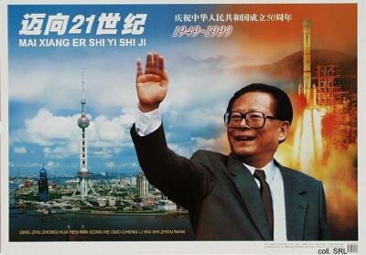
Jiang Zemin was born in Yangzhou, Jiangsu Province, in 1926. He graduated from Shanghai Jiaotong University with a degree in electrical engineering in 1947. In 1943, while a student, he took part in CCP-led student activities against Chiang Kai-shek. He joined the Party in 1946.
Under the patronage of Wang Daohan, he was recruited into the First Machine-Building Ministry in 1952, serving in various units. In 1955-1956, he studied at the Stalin Automobile Works in Moscow. Upon his return to China, he was assigned to the Changchun No. 1 Vehicle Plant, the home of the Jiefang (Liberation) truck. In the following years, Jiang the technician evolved into Jiang the bureaucrat. During the Cultural Revolution, he was sidelined in Wuhan. After 1976, he returned to his old Ministry. When Deng Xiaoping embarked on his reform program in 1978, Jiang's reputation again was in the ascendant. Being involved with the creation of the Special Economic Zones in the South, he was seen as part of the group of reformers allied with Hu Yaobang and Zhao Ziyang. In 1982, he joined the CCP Central Committee.
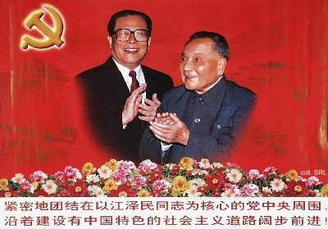
In 1985, Jiang was made mayor of Shanghai. Although not very popular with the population, he impressed many foreign business people and politicians with his plans for economic reconstruction. After his elevation to the Politburo in 1987, he concurrently served as Party secretary of Shanghai, while the more popular Zhu Rongji replaced him as mayor.
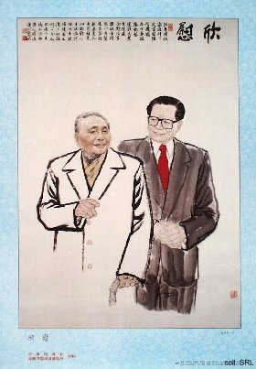
Jiang was picked by Deng Xiaoping to replace Zhao Ziyang as CCP general secretary in the days preceding the Tian'anmen Incident in June 1989. His promotion seems to have been based on the fact that he was able to defuse student demonstrations in Shanghai in a non-confrontational manner. Moreover, even though he supported the CCP-decision to invoke martial law in Beijing, he was not associated directly with the bloody PLA-actions on the Square that followed. Once Deng retired in the fall of 1989, it was up to Jiang to formulate new, acceptable policies that were supported by all factions. But Deng's withdrawal from public life was mainly a cosmetical one. On the basis of the extensive connections (guanxi) Deng had formed in his long revolutionary career in the Party, the army and the bureaucracy, he remained the strongest political factor in China until his death in 1997.
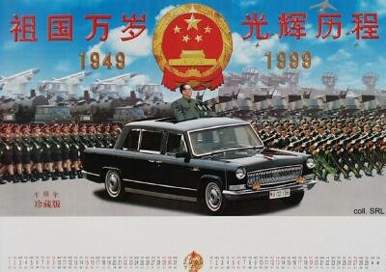
Jiang used the years he was in waiting to strengthen his personal power base, which at the outset was virtually non-existent. In doing so, he—once seriously underestimated—has shown adroit political gamesmanship in substituting the aging revolutionary guard as well as potential competitors with his own protégés and allies. Nonetheless, his public image has not always been very positive. Critics and detractors have dubbed him as a "karaoke-crooning, poetry-spouting buffoon", a panda bear, a "flowerpot" or a weathercock (because of his ability to change colors and positions quickly).
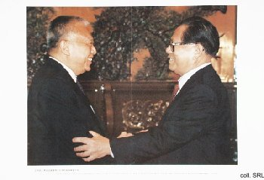
In 1994, Jiang was officially confirmed as Deng's successor. In that capacity, he added the positions of President of the People's Republic and Commander-in-Chief of the armed forces to his résumé. From that point on, Jiang started to build up a minor personality cult: his writings were published, and posters started to appear which showed him and his benefactor. When Deng died in February 1997, Jiang was catapulted into the limelight. He made a lasting impression with his tearful funeral oration at Deng's casket, pledging to persevere in his predecessor's footsteps; and he presided over the Hong Kong Handover in July of that year. Moreover, he has been advocating the inclusion of "Deng Xiaoping Theory" in the canon. This has as yet not resulted in the addition of Deng's portrait to the pantheon of Marxist theory.
Jiang's political stature has increased significantly as a result of a number of recent developments. First, Jiang reaped the credits for the return of Macao (Aomen) to Chinese sovereignty (1999). Secondly, he presided over China's accession to the World Trade Organization (2001-2002). Moreover, during his reign, the PRC was picked to host the Olympic games in 2008. At the same time, Jiang has been actively working on his own contribution to China's ideological complex. In 2000, his theory of the "three represents" was first presented. The theory focusses on the future role of the CCP as "a faithful representative of the requirements in the development of advanced productive forces in China, the orientation of the advanced culture in China, and the fundamental interests of the broadest masses of the people in China."
Sources:
Zhongguo renwu nianjian 2000 [Who's Who in China 2000] (Beijing: Zhongguo renwu nianjian chubanshe, 2000) [in Chinese]
Dachang Cong, When Heroes Pass Away—The Invention of a Chinese Communist Pantheon (Lanham MD, etc.: University Press of America, 1997)
Bruce Gilley, Tiger on the Brink—Jiang Zemin and China's New Elite (Berkeley, etc.: University of California Press 1998)
Ye Duchu et al. (eds), Dangyuan ganbu "sange daibiao" duben [The "three represents" reader for Party members and cadres] (Beijing: Hongqi chubanshe, 2000) [in Chinese]

