He Long

The pipe-smoking He Long (1896-1969) was one of the more colorful of the marshals. Born in Sangzhi, Hunan Province, he was the son of a minor military officer who was a member of the Gelaohui (Elder Brother Society), a secret society dating from the beginning of the Qing dynasty. He, who was a cowherd during his youth, received no formal education, and as late as the 1930s, he was still only semi-literate.
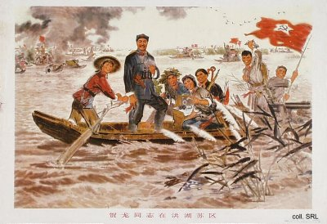
According to some accounts, He was something of a modern Robin Hood, stealing from the rich while protecting the poor. This view is based on recollections that He killed a local magistrate, who had murdered his uncle, and afterwards became an outlaw. By the mid-1920s, he had emerged as an important local military figure, and in 1927, he was recruited for, and joined, the CCP. During the Long March, he emerged as a supporter of Mao's strategies.
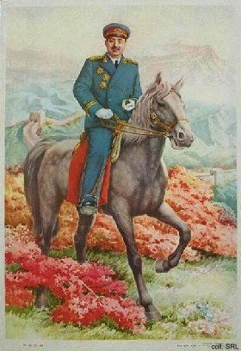 | 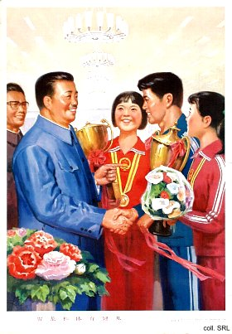
After the founding of the PRC, the pipe-smoking He headed the National Sports Commission. He was made a marshal in 1955. He Long was branded as an anti-Party element and purged in 1966. He died in prison.
Sources:
Wolfgang Bartke, Who was Who in the People's Republic of China (München: K.G. Sauer, 1997)
Wolfgang Bartke, Biographical Dictionary and Analysis of China's Party Leadership 1922-1988 (München: K.G. Sauer, 1990)
Donald W. Klein & Anne B. Clark, Biographic Dictionary of Chinese Communism (Cambridge, MASS: Harvard University Press, 1971)
Liao Yiwen (ed), Tian Lun [Family Love and Friendship) (Tianjin: Tianjin jiaoyu chubanshe, 1995)
Yang Kelin (ed.),Wenhua dageming bowuguan [Museum of the Cultural Revolution] (Hong Kong: Dongfang chubanshe youxian gongsi, Tiandi tushu youxian gongsi, 1995) [in Chinese]

