Deng Xiaoping

Deng Xiaoping (1904-1997) was born as Deng Xiansheng into a landlord family in Guang'an District, Sichuan province. At the age of 15, Deng was sent by his father to a preparatory school in Chongqing. A year later, Deng left for France, where he participated in the work-study program for Chinese students. In 1922, Deng joined the China Socialist Youth League. Among his associates was Zhou Enlai. When the Communist Party called its members home in 1926, Deng stopped in Moscow for a few months of extra study.
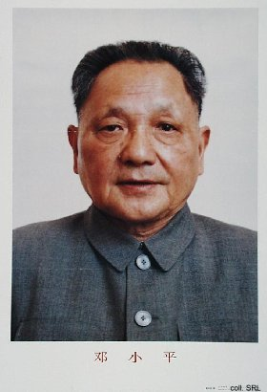
In 1927, he changed his name to Xiaoping, meaning "small peace". After returning to China, he played a role in organizing the Red Army, the predecessor of the People's Liberation Army (PLA). During the Long March, Deng was Secretary-General of the Central Committee. While acting as the political commissar of the Eight Route Army commanded by Liu Bocheng, he masterminded a number of important military campaigns during the war against Japan and during the Civil War against the Guomindang.
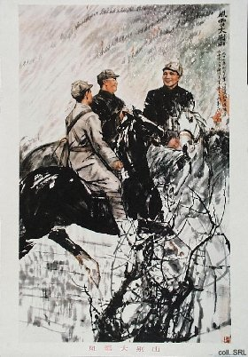
After the founding of the People's Republic of China in 1949, Deng held a number of important military and civilian posts: Member of the General Staff of the PLA; Member of the Central Committee; Member of the Politburo; Secretary-General of the CCP; Vice-Premier of the State Council. However, Deng and Mao Zedong clashed when the Great Leap Forward (1957-1958) failed.
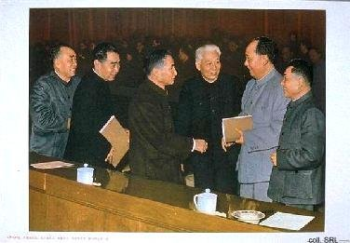
In 1966, Deng and Liu Shaoqi became the major targets of struggle during the Cultural Revolution. They and Mao basically disagreed on the course of development China ought to take. Mao, moreover, feared that Liu's and Deng's policies would tarnish his revolutionary status. Deng was prosecuted by Red Guards, lost all his positions and was sent into internal exile.
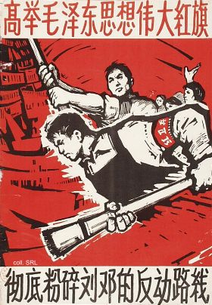
In early 1973, Deng was rehabilitated on the recommendation of Zhou Enlai. A year later, he re-entered the Politburo. Deng attempted to consolidate his power base but was not yet strong enough to oppose Mao's wife, Jiang Qing and the Gang of Four. When Zhou died in January 1976, Deng delivered the memorial service eulogy. Three months later, the Gang of Four blamed Deng for instigating bloody riots in Tiananmen Square and during the campaign to criticize rightist deviation, he was purged for the second time.
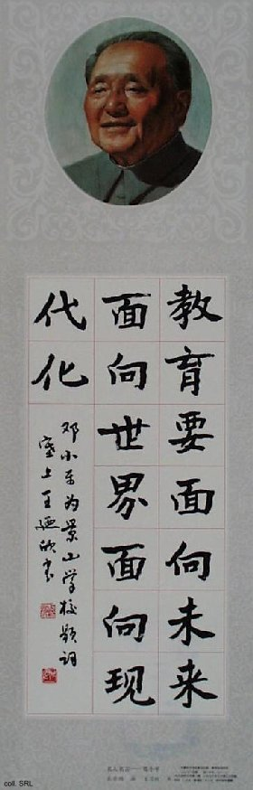
Deng's excellent connections in the Army, Party and State bureaucracy enabled him to resume work once the Cultural Revolution had ended. By 1977, these same connections enabled him to sideline Mao's designated successor Hua Guofeng, and to nominate his own protegees, including Hu Yaobang and Zhao Ziyang, in key positions. Having thus secured his political base, he succeeded in having adopted his plans for the urgent modernization of the economy in December 1978. This strategy, the Four Modernizations (of agriculture, industry, national defense and science & technology) was based on a blueprint that he and Zhou Enlai had drawn up in the early 1970s. As a result, Deng is widely seen as the "Chief Architect" of the Chinese economic reforms.
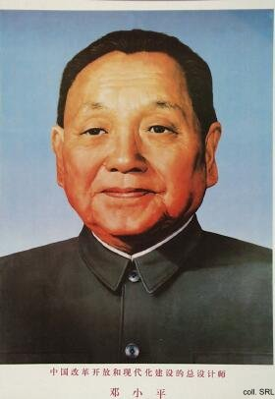
In the political arena, Deng was active in neutralizing the harmful effects of Mao's radical policies that had culminated in the Cultural Revolution. On the basis of Mao's dictum "seek truth from facts" that Deng propagated, a new pragmatism could take root in Chinese politics. With the "One Country, Two Systems"-principle that he formulated, China was able to resume sovereignty over Hong Kong (1997) and Macao (1999).
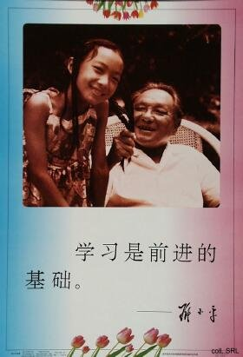 | 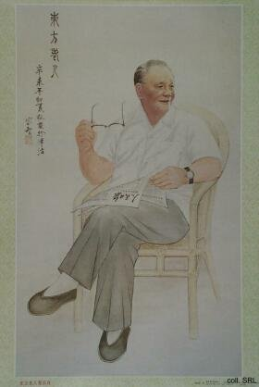
Deng's reputation was tarnished by his role in the 1989 crackdown. While blame for ordering the troops in was pinned on lower-ranking leaders, there seems little doubt it was Deng who gave the crucial order to shoot to kill. With Deng's semi-retirement from public life after the Tian'anmen Incident in 1989, the Propaganda Department finally saw an opportunity to build up a cult around the "Chief Architect" of reform. In November 1992, after Deng had made an inspection tour of the Southern, most advanced and prosperous provinces and regions, a portrait of him, done in typical brushwork style, was released as a poster. This turned out to be the opening salvo of an avalanche of Deng-related materials in the years to follow. A year later, posters appeared that featured Deng's more remarkable remarks ("We should do more, and engage in less empty talk", amongst others), against a backdrop of either a photomontage of a modern city skyline, or flower arrangements reminiscent of the 1950s. In 1994, a complete set entitled "Beloved comrade Xiaoping", devoted to important moments in his life, was published.
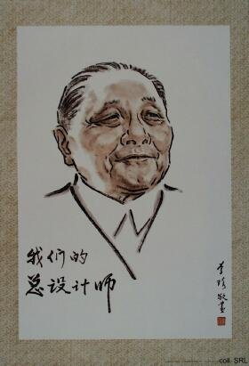 | 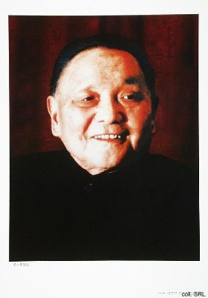
With Deng's demise in February 1997, the market was flooded with "Deng posters". People did not simply buy the images; trinkets, memorabilia and outright kitsch, such as watches bearing Deng's portrait, were also quite en vogue for a while. It seems as if Deng, with his health decreasing, had been less and less able to keep the Party propaganda machinery—and his successor Jiang Zemin—from using him as a propaganda object. Jiang has also been the moving force behind the canonization of Deng Xiaoping Theory.
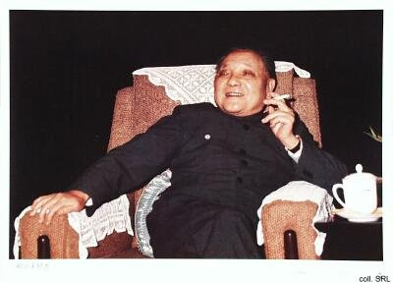
In 1928, Deng married his first wife Zhang Xihuan, who died two years later. After the Long March, in Yan'an, Deng met and married Pu Chiungying, who changed her name to Zhuo Lin. They had three daughters and two sons.

Beloved comrade Xiaoping

In 1994, a complete set devoted to important moments in Deng Xiaoping's life, was published. Entitled "Beloved comrade Xiaoping", it was a break with Deng's desire to stay out of the limelight of propaganda and personality cult.
The set presented below is, unfortunately, not complete. Two posters from Deng's early life, including one as a student in France, are (still?) missing.
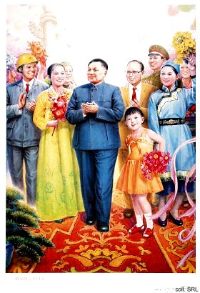 | 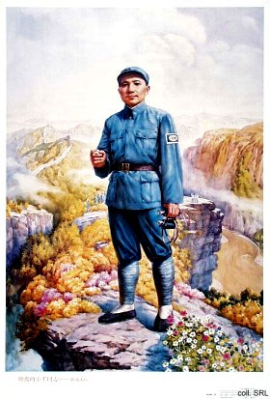

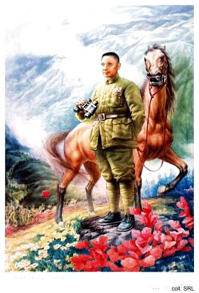 | 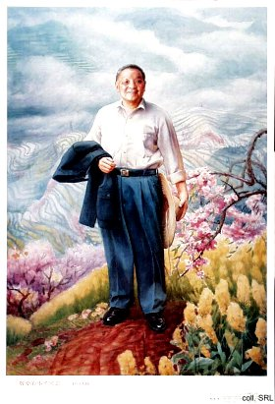

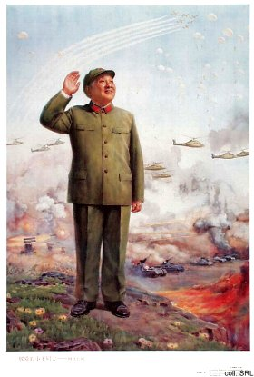 | 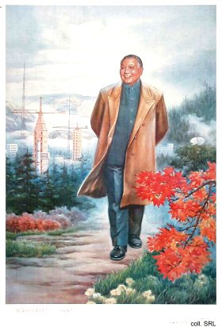

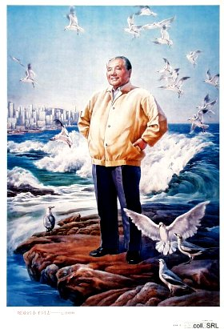

Deng Xiaoping Theory

Deng Xiaoping Theory encapsulates the various policy pronouncements that guided the reform process that started in 1978. The Theory can be seen as a major departure from Mao Zedong Thought, as Deng insisted that "economic development is the centre of party work". Two of the late patriarch's famous dicta were: "It always stands to reason to develop the economy faster" and "The economy must cross a new threshold every few years." Deng's development plan resulted in tremendous development, explosive growth and the first traces of a consumer society. At the same time, it engendered undesirable consequences that affect stability and the potential for the party's continued rule. They include polarisation of rich and poor; a big gap between coastal and western China; rank corruption; and the neglect of indoctrination in Communist orthodoxy in particular.
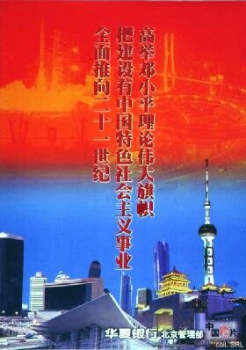
In foreign policy, Deng formulated the theory that China should "adopt a low profile and never take the lead". And given his country's dependence on the American market as well as its investment and technology, Deng's main policy towards the United States was to avoid confrontation. In concert with his foreign policy, Deng saw the People's Liberation Army as a mainly defensive force. His major contributions included the massive demobilisation and budget cuts in the 1980s and early 1990s.
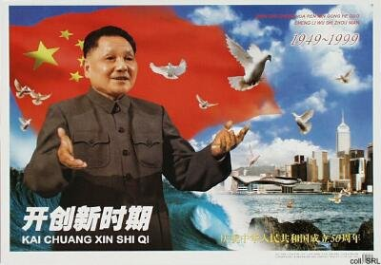
After Deng's death in 1997, Jiang Zemin has been instrumental in having Deng Xiaoping Theory included in the canon of Marxism-Leninism, Mao Zedong Thought. This has as yet not resulted in the addition of Deng's portrait to the pantheon of Marxist theory.
Sources:
Deng Xiaoping, Selected Works
Information Network of the Guangdong Provincial Research Center for Deng Xiaoping Theory [in Chinese]
Willy Wo-Lap Lam, "Jiang still thinking it through", South China Morning Post, 5 January 2000

