Great Leap Forward

As a result of the successful economic reconstruction that had taken place in the early 1950s, the Party leadership headed by Mao Zedong considered the conditions ripe for a Great Leap Forward in early 1958. The Chinese people were to go all out in a concerted effort to surpass England in 15 (or even less) years. That, at least, was the plan, which brought to an abrupt stop earlier, more cautious attempts to sustain the speed of China's recovery and further development. The more radical members of the leadership tried to outdo each other with more and more unrealistic calls for "greater, faster, better, [and] cheaper" production.
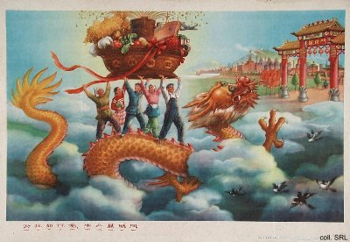
On the basis of an exaggerated belief in the power of ideology on human consciousness, they were convinced that the objective difficulties created by lagging industrialisation and mechanisation could be overcome in a relatively short time. By relying on will power, and by giving supremacy to the human, subjective dimensions of history, the people would be able to bring about a quick transformation of the concrete obstacles they encountered in the physical world. To mobilize this will power, the Great Leap Forward, obviously, was accompanied by a concerted propaganda effort, the depth and breadth of which had hitherto not been seen.
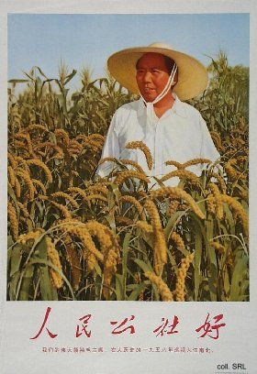
The Great Leap Forward took two forms: a mass steel campaign, and the formation of the people's communes. On the one hand, all the people in the country were organized to help produce the amount of steel that was needed to attain the goal of surpassing England. Life was militarized for this battle for steel. Everywhere, small backyard furnaces were built, where everybody pitched in in around-the-clock shifts. Quota for the collection of used iron had to be met, cooking pots were smashed, door handles were melted down in order to meet the production demands. Only later it became clear that the quality of this mass-produced people's steel was so poor that no use could be found for it. The effects of this production battle proved to be disastrous for the environment. On the poster below, on the left, rows of such small backyard furnaces can be seen.
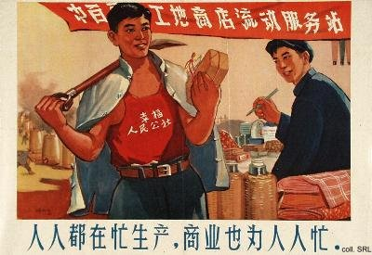
In the countryside, the various forms of rural cooperatives were merged into huge people's communes. Rural life was completely collectivized, including mess halls where free food was supplied. Due to the excessive zeal of local officials, who were whipped up in the general atmosphere of enthusiasm while at the same time afraid to be branded as laggards, production figures that were unrealistic to begin with, were fixed higher and higher. Moreover, because everybody was involved in the battle to produce steel, labor power was lacking to bring in the harvests. If these amounts of food really could have been harvested, as the enthusiastic reports had promised, "communism was just around the corner", as the general belief in the autumn of 1958 seemed to be.
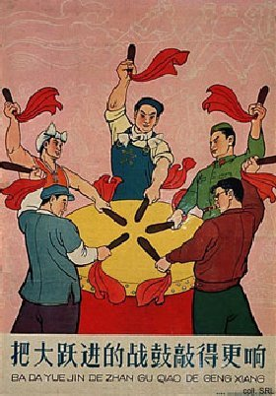
By early 1959, it became clear that things were running out of hand. As a result of the massive production drives in steel and agriculture, both production and transport sectors had become severely dislocated. The reality of the Great Leap Forward corresponded less and less with the picture painted in the reports to the leadership. Some leaders, including Chen Yun, started to express cautious warnings about the results of this "fever in the brain" which held China in its sway, while the more radical officials continued to proclaim imaginary victories in production. Dissatisfaction climaxed at the Lushan Plenum in July 1959. Originally, the meeting was intended to reign in the "leftism" of the movement, but it turned into a showdown between proponents of the movement (headed by Mao) and opponents (inadvertently headed by Minister of Defense Peng Dehuai). In a personal letter to Mao, Peng had criticized the extreme elements of the movement. Mao interpreted the letter as an attack and had it distributed for study and criticism by the other leaders present at Lushan. As a result of the Plenum, Peng was dismissed from his posts and replaced by Lin Biao. Instead of trying to find answers to the problems of the Great Leap, an anti-Rightist struggle was started.
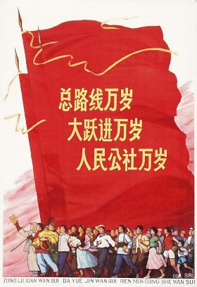 | 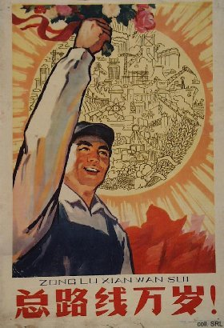
Despite the indications that the Great Leap had failed to reach its objectives, the movement continued to be upheld. During the celebrations of the Tenth Anniversary of the People's Republic in October 1959, the "General Line of the Great Leap Forward, the people's communes and the steel campaign" were reaffirmed. The movement turned into a disaster when in the period 1959-1961 China was struck by natural disasters. More than an estimated 23 million people died in the ensuing famine. Moreover, as a result of the break-up of the relations with the Soviet Union, China was confronted with total economic collapse. The readjustment of the economy started in 1961, and took place under the leadership of Liu Shaoqi, Deng Xiaoping, Chen Yun and others. Mao accepted the responsibility for the disasters and withdrew to Shanghai. From here, he plotted his return to the pinnacle of power, which resulted in the Great Proletarian Cultural Revolution.
Sources:
China Famine 1959-61 [in Chinese]
Li Rui, Lushan huiyi shilu [True Record of the Lushan Plenum] (Peking: Chunqiu chubanshe/Hunan jiaoyu chubanshe, 1989) [in Chinese]
Li Zhisui, The Private Life of Chairman Mao—The Memoirs of Mao's Personal Physician (London, etc.: Random House, 1996)
Roderick MacFarquhar, The Origins of the Cultural Revolution, Volume II: The Great Leap Forward, 1958-1960 (Columbia University Press, 1987)
Frederick Teiwes and Warren Sun, China's Road to Disaster—Mao, Central Politicians, and Provincial Leaders in the Unfolding of the Great Leap Forward 1955-1959 (Armonk: M.E. Sharpe, 1998)

