Up to the mountains, down to the villages (1968)

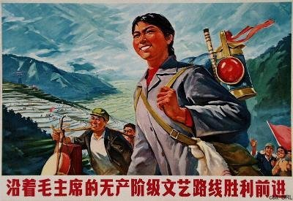
From December 1968 onward, millions of urban youth (secondary school graduates and students) were mobilized and sent "up to the mountains and down to the villages" (shangshan xiaxiang), i.e. to rural villages and to frontier settlements. In these areas, they had to build up and take root, in order to be reeducated by the poor and lower-middle peasants.
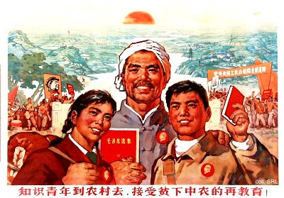
This relocation program was practiced first on a limited scale before the Great Leap Forward Movement, resumed in the early 1960s, and accelerated sharply by the late 1960s.
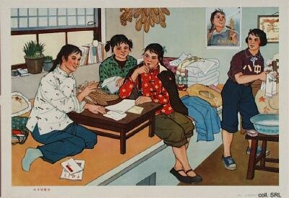
While some 1.2 million urban youths were sent to the countryside between 1956 and 1966, no less than 12 million were relocated in the period 1968-1975; this amounts to an estimated 10% of the 1970 urban population. In principle, the program called for lifelong resettlement in the rural areas, but toward the end of, and in particular after the Cultural Revolution, many were finally able to find jobs or to be transferred back to the cities. A great number of them, however, had resigned themselves to their fate and decided to remain.
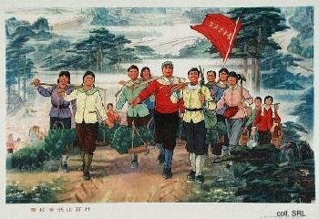 | 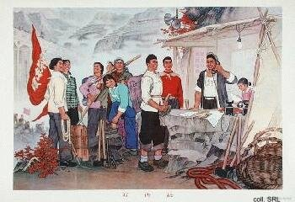
Judging from the many posters that were dedicated to shangshan xiaxiang, showing idyllic rural scenes, the youngsters all enjoyed the wholesome life in the countryside, and thrived under the stern but correct ideological guidance provided by the peasants. All this should transform them into "new-style, cultured peasants". The young intellectuals were also seen as conveyor belts for technology transfer, as bringers of new knowledge. In reality, and similar to the 7 May cadre school program, however, many peasants living in the areas where urban youths were resettled resented their arrival. They often saw the youngsters from the cities, who in their eyes did not amount to much in terms of labor power, as a threat to their own survival. Many students could not deal with the harsh life and died in the process of reeducation.
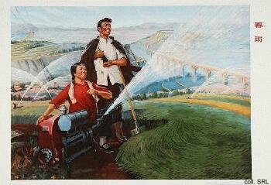 | 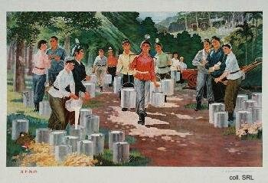
The main reason behind the acceleration of the relocation program in 1968 was an attempt to bring the Red Guards under control and to halt the intense factional struggle and civil strife. With the schools still closed, the government did not know what to do with the millions of urban young. One way to solve the problem was to send the students away to the rural areas and let them fend for themselves. Over the years, many of those who were sent away slowly started to realize this. Although the resentment this created found something of an outlet during the "Beijing Spring Movement" of 1978-1980, it contributed to a general decline of support for the Party, and apathy for all things political.
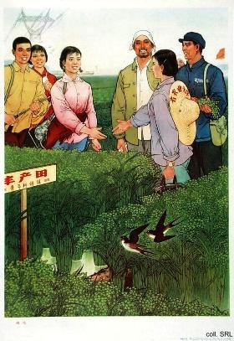 | 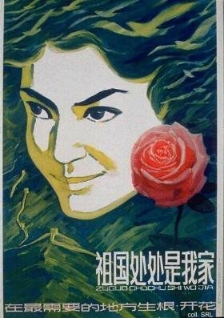
Despite the negative experiences of many, the government reintroduced a reallocation program in the 1980s—an elective one, this time. Few people were interested, unless they managed to secure extra allowances or hardship pay.
External Links:
Old Pictures from China, taken by Herbert Chang who was sent to the countryside in 1968. In 1999, he returned and has photographed scenes for comparison
The Red Guards

Sources:
Thomas P. Bernstein, Up to the Mountains and Down to the Villages—The Transfer of Youth from Urban to Rural China (New Haven, etc.: Yale University Press 1977)
Yarong Jiang & David Ashley (eds.), Mao's Children in the New China—Voices from the Red Guard Generation (London, etc.: Routledge 2000)
Kwok-sing Li (editor) & Mary Lok (translator), A Glossary of Political Terms of the People's Republic of China (Hong Kong: The Chinese University Press 1995)
Michael Schoenhals (ed.), China's Cultural Revolution, 1966-1969—Not A Dinner Party (Armonk NY: M.E Sharpe 1996)

