Study Theory (1975)

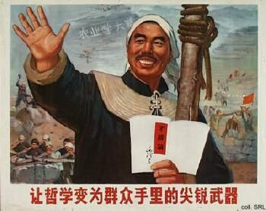 | 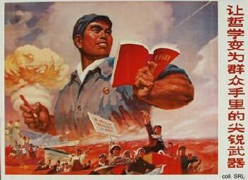
The historical issues at stake in, and the theoretical debates surrounding, the campaign to criticize Shuihu zhuan were too obscure for most Chinese. In order to mobilize the people, and the workers in particular, the campaign's criticism of "capitulationism" was linked with renewed calls to study the theories of Marx, Engels, Lenin, Stalin and Mao.
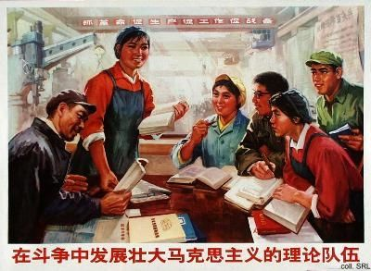
The theory singled out most for study in 1975 was that of the dictatorship of the proletariat. As the People's Liberation Army was considered to be the organization that was to enforce this dictatorship, the leadership hoped to avert the repudiation of the Cultural Revolution and at the same time boost the low morale of the Army.
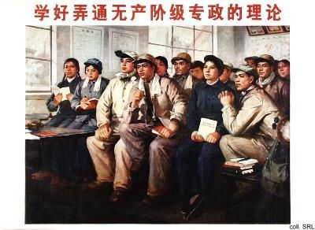

Source:
Kwok-sing Li (editor) & Mary Lok (translator), A Glossary of Political Terms of the People's Republic of China (Hong Kong: The Chinese University Press 1995)

