Revolutionary Networking

In the Summer of 1966, when the Cultural Revolution got underway, many emerging groups of Red Guards felt repressed in their revolutionary fervor by school and university authorities who attempted to keep the situation under control. The Red Guards wanted to go to Beijing and Chairman Mao to look for justice and sympathy, and to share their experiences with other groups. This formed the beginning of a period of revolutionary networking (chuanlian) which lasted from August 1966 until March 1967. While many came by train and car, thus overburdening the transport infrastructure, those who walked all the way to Beijing were considered to be truly demonstrating their revolutionary credentials.
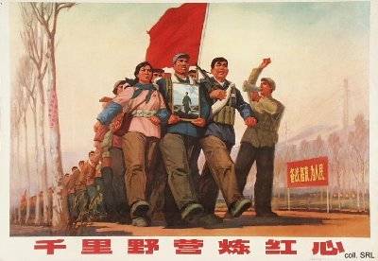
Beijing was the center of the networking movement. Millions of Red Guards piled into the city. Classrooms and university dormitories were turned into reception stations. The networkers received free meals, for they were "guests of Chairman Mao". The Red Guards also were given free transport passes within the city and free admission to parks. The greatest reward, of course, was to catch a glimpse of Mao. To this end, ten "audiences" were organized, on 18 and 31 August, 15 September, 10 and 18 October, and 3, 10, 11, 25 and 26 November 1966, where Mao 'inspected' millions of Red Guards. These mass receptions contributed to the further worship and deification of Mao, and helped him to vanquish local political and Party resistance to the Cultural Revolution.
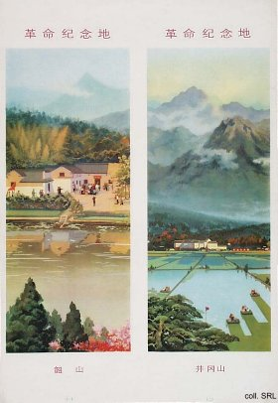 | 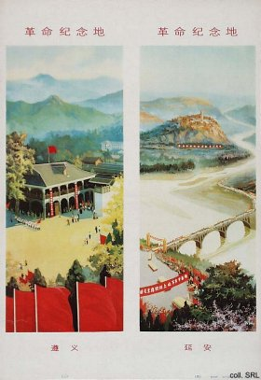
After having visited Beijing, the Red Guards swarmed out all over the country. Some went to Mongolia, others to Xinjiang, or Guilin, or Shanghai. But the places where the Long March had passed through provided great drawing power for many youngsters who considered themselves to be on a Long March of their own. These destinations included Shaoshan (Mao's birth place), Jinggangshan (the cradle of the Communist Party), Zunyi (where Mao had become the leader of the Party), Luding Bridge (where a heroic crossing over the Dadu River took place), and Yan'an (the revolutionary base area where the Party's policies had emerged and matured during the 1930s and 1940s).
However, all this travelling of millions of people led to an enormous congestion. By the end of 1966, the Central Committee sent out calls to terminate the movement, and the Red Guards were urged to return home and continue conducting the Cultural Revolution there. By February 1967, all reception stations and liaison offices were closed. The movement was seen as having served its political purpose. For many youngsters, however, this had been the first time they had been able to travel and see their country.
Shaoshan | Jinggangshan
Zunyi | Luding Bridge
Yan'an

Sources:
Gao Yuan, Born Red—A Chronicle of the Cultural Revolution (Stanford: Stanford University Press, 1987)
Yan Jiaqi & Gao Gao (translated & edited by D.W.Y. Kwok), Turbulent Decade—A History of the Cultural Revolution (Honolulu: University of Hawai'i Press 1996)
Yang Kelin (ed.), Wenhua dageming bowuguan [Museum of the Cultural Revolution] (Hong Kong: Dongfang chubanshe youxian gongsi, Tiandi tushu youxian gongsi 1995) [in Chinese]
Shaoshan

Shaoshan, Hunan Province, is a small village some 100 kilometers from the provincial capital Changsha. Mao's old home, a more substantial house than the others, is in a small side valley just below the village square. During the Cultural Revolution, Shaoshan became the sacred place of pilgrimage for millions of Chinese, eclipsing destinations such as Jinggangshan (the cradle of the Communist Party), Zunyi (where Mao had become the leader of the Party), Luding Bridge (where a heroic crossing over the Dadu River took place), and Yan'an (the revolutionary base area where the Party's policies had emerged and matured during the 1930s and 1940s). In the peak year of revolutionary networking (1966), some three million people visited the village.
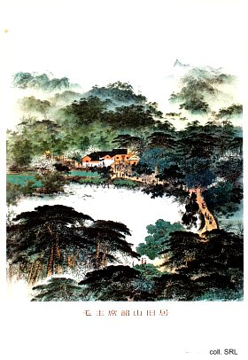
Mao's ancestral home was restored in the early 1950s. The village as a whole greatly benefitted from the posting of Hua Guofeng in Xiangtan, the district in which Shaoshan is located. By personally overseeing various projects, including an irrigation project, he was able to catch Mao's attention in an early phase. This boosted his political capital in the following years.
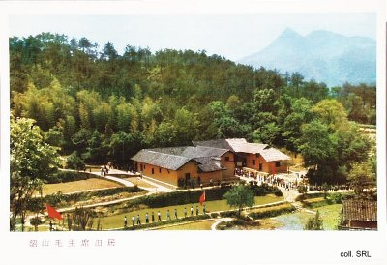
Whereas Mao himself only returned twice (in 1959 and 1966) to his native village after the founding of the PRC, all national leaders have made their pilgrimage to Shaoshan over the years.

Sources:
John Gittings, Real China—From Cannibalism to Karaoke (London, etc.: Simon & Schuster, 1996)
Shaoshan Mao Zedong jinianguan (eds), Mao Zedong shenghuo dang'an (quan san juan) [Life File of Mao Zedong (3 vols.)] (Beijing: Zhonggong dangshi chubanshe, 1999) [in Chinese]
Yan'an

At the end of the Long March, the surviving remnants of the Communist Party and the People's Liberation Army reached the desolate and desperately poor area of Yan'an, Shaanxi Province. In what was to become known as the Yan'an Period (1935-1947), most of the policies of the CCP that had been started in the Jiangxi Soviet were further refined and many others were first tried out. Here, the lingering influence of the Soviet Union in the fields of organization, politics and strategy, was replaced by a specific Chinese interpretation of how things were to be done. It was from here that the image of an upright and patriotic CCP spread to become a feasible alternative for the increasingly corrupt and inept Guomindang. In Yan'an, Mao Zedong's personal rule within the Party was consolidated; Mao Zedong Thought was formed; policies were set that were to guide literature and arts until the present day; rectification movements were employed to maintain discipline; friendships were formed, and antagonisms emerged that would be fought out during the Cultural Revolution; and the "mass line" ("from the masses, for the masses") was developed. It would all contribute to the formation of a myth that even today remains powerful among Party leaders.
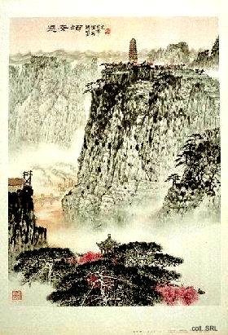 | 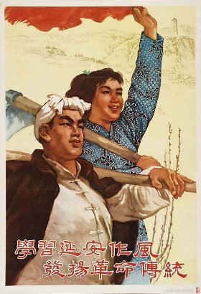
During the period of revolutionary networking (chuanlian, 1966-1967), intended for the Red Guards to exchange revolutionary experiences, Yan'an was turned into a place of pilgrimage. The same happened with Jinggangshan, Ruijin, Shaoshan (Mao's birthplace), Luding and Zunyi.

Sources:
David Apter & Tony Saich, Revolutionary Discourse in Mao's Republic (Cambridge: Harvard University Press 1994)
Mark Selden, The Yenan Way in Revolutionary China (Cambridge: Harvard University Press 1971)
Edgar Snow, Red Star over China (Grove Press 1973)
Jinggangshan

After the Guomindang (GMD) turned against the Communist Party during the Shanghai Massacre of 1927, the communists either went underground or fled to the countryside. In Jinggangshan, located in the border region between Hunan and Jiangxi Provinces, Mao Zedong set up his first peasant soviet. Security was provided by Zhu De and his remaining troops. Other veterans who joined the new base included Lin Biao and Zhou Enlai. From Jinggangshan, various attempts were made to start the revolution. In the winter of 1928-1929, the organization moved to Ruijin, Jiangxi Province, where the Jiangxi Soviet was set up. Here, the forerunner of the People's Liberation Army was formed; here, the Party started organizing the peasantry as its mass base; here, a start was made with land reform. Eventually, in 1934, GMD troops would force the CCP out of Jiangxi on its Long March, which ended in Yan'an a year later.
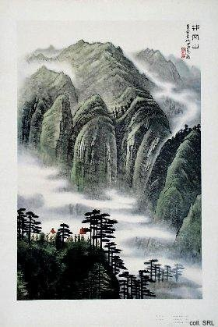 | 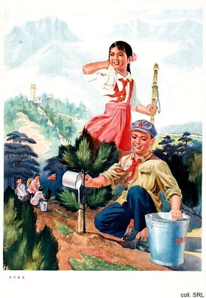
During the period of revolutionary networking (chuanlian, 1966-1967), intended for the Red Guards to exchange revolutionary experiences, Jinggangshan was turned into a place of pilgrimage. The same happened with Ruijin, Shaoshan (Mao's birthplace), Luding, Yan'an and Zunyi.

Luding Bridge

The crossing of the Dadu River (Sichuan Province) during the Long March was a truly heroic feat. The number of available boats was inadequate, and the Luding Bridge, an iron chain structure built during the Qing dynasty, was the only alternative for the communists to move further to Yan'an.
The suspension bridge consists of thirteen chains, nine forming the floor, covered with planking, with two chains on either side. When the troops of the vanguard unit led by Lin Biao reached the bridge on 29 May 1935, they discovered that the KMT Army units at the opposite end had removed two-thirds of the planking; the remaining flooring had been set on fire. An advance unit of 22 men was ordered to take the bridge. They inched their way over the chains under enemy machine gun fire and were able to reach the other side, routing the KMT troops. Eighteen of the 22 survived the crossing. After another two hours, Luding Bridge was securely in the hand of the Party and the Red Army.
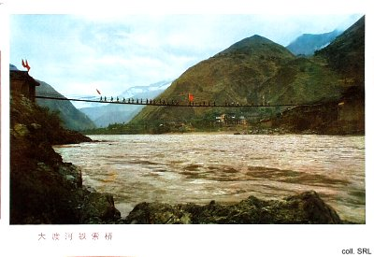
The crossing of the Dadu River contributed greatly to the myth surrounding the Long March and those taking part in it. From this point on, the Red Army was said to be made up of "supermen". The Party used the crossing for its own purposes as well, turning it into a huge propaganda effort. Over the years, many movies were made, dedicated to the soldiers' heroism. Having been etched onto the collective consciousness, the Luding Bridge became a must-see destination for Red Guards during the period of revolutionary networking (1966).
Source:
Harrison E. Salisbury,The Long March—The Untold Story (New York, etc.: Harper & Row Publishers, 1985)

