Revolutionary Committees (1967)

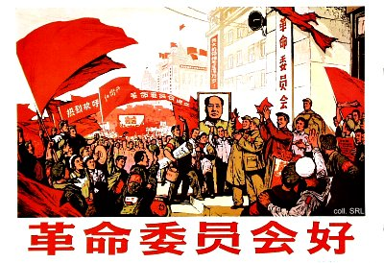
On 24 January 1967, Mao Zedong renamed the Shanghai People's Commune as the Shanghai Revolutionary Committee. These Committees, which were supposedly based on a "three-way alliance of Red Guards, Party cadres and army men", were to replace the original political structures that had existed until then in China and to bring the factional struggle to an end. The term "revolutionary committee" itself originated in the Soviet Union, where it refered to a power structure which combined the military and the state.
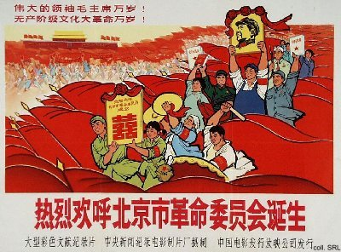
The formation of the revolutionary committees was the result of the power seizures by rebel and Red Guard factions. Only by 5 September 1968, the committees were set up in all provinces, municipalities and autonomous regions, "with the exception of Taiwan". Although Mao himself had allowed that the committees were merely provisional organs of power, they remianed in existence until 1979, when they were abolished and replaced by people's governments at all levels.
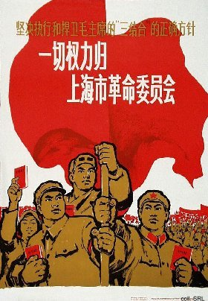 | 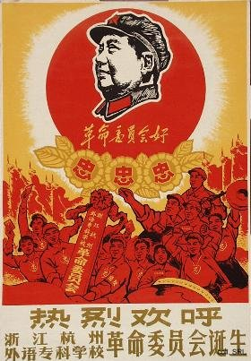

Sources:
Kwok-sing Li (editor) & Mary Lok (translator), A Glossary of Political Terms of the People's Republic of China (Hong Kong: The Chinese University Press 1995)
Michael Schoenhals (ed.), China's Cultural Revolution, 1966-1969—Not A Dinner Party (Armonk NY: M.E Sharpe 1996)

