Quotations from Chairman Mao

The Quotations from Chairman Mao, the Mao zhuxi yulu, were culled from the numerous writings in which Mao had set out to sinify Marxism-Leninism over the years. Already in Yan'an, Mao was styling himself as the sole theoretician of Chinese communism, on a par with Marx, Engels, Lenin and Stalin. As a result, his writings were known as Mao Zedong Thought. In the early 1960s, and during the first phase of the Cultural Revolution, the People's Liberation Army under Lin Biao played a major role in the popularization of the Quotations. Only in the early 1980s, when the official, negative, verdict of the Cultural Revolution was formulated by the CCP, it was decided that the ideological repository originally attributed to Mao was—in reality—the crystallized wisdom of all the leaders of the Chinese revolution.
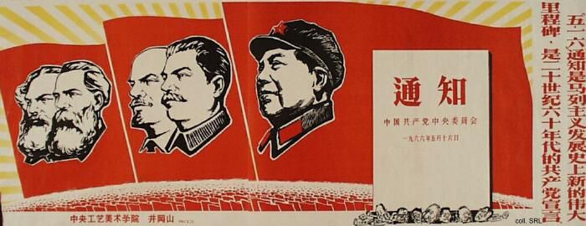
Although printed in staggering numbers (some 740 million by 1968), the "Little Red Book", as it became known in the West, was not the only medium through which Mao Zedong Thought was spread. The Renmin ribao (People's Daily), the mouthpiece of the Party, carried a daily changing Mao-quote printed in red in its masthead, to supplement the abundant number of quotes in boldface which peppered the articles. A number of quotes were reproduced on posters and these were given the place of honor wherever they were displayed.
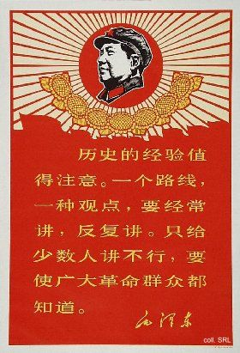 | 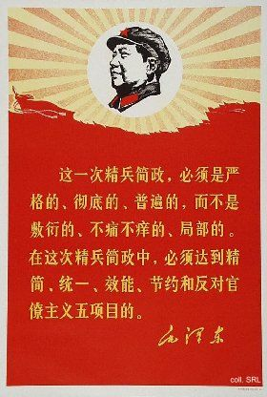
Regularly, so-called Chairman Mao's Latest Instructions were published. These utterings of profound wisdom were to be welcomed with great fanfare, with gongs and cymbals. All work was stopped, and people were even told to get out and hail their arrival in the streets.
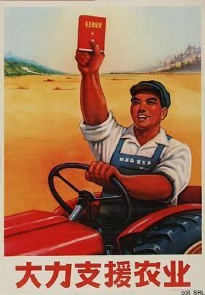 | 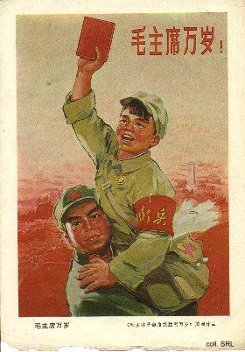
External Links:
Quotations from Mao Zedong
Sayings of Chairman Mao has some of Mao's quotations in Chinese, with ethymological explanations in English, by sinologist Rick Harbaugh.
Sources:
Geremie Barmé, Shades of Mao—The Posthumous Cult of the Great Leader (Armonk, N.Y.: M.E. Sharpe 1996)
Yan Jiaqi & Gao Gao (translated & edited by D.W.Y. Kwok), Turbulent Decade—A History of the Cultural Revolution (Honolulu: University of Hawai'i Press 1996)
Yang Kelin (ed.), Wenhua dageming bowuguan [Museum of the Cultural Revolution] (Hong Kong: Dongfang chubanshe youxian gongsi, Tiandi tushu youxian gongsi 1995) [in Chinese]

