Criticize Rightist Deviationism (1976)

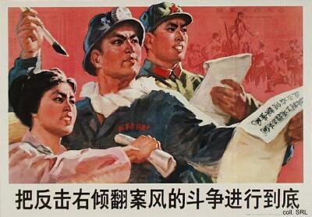
One of the last campaigns engineered by the Gang of Four during the Cultural Revolution was the one to criticize Rightist Deviationism in Spring 1976. The immediate cause was the outporing of popular support after the death of Zhou Enlai in January. This did not take place right after Zhou had succumbed of cancer, but during the Qingming Festival in April. Official ceremonies had been kept to a bare minimum by the Gang and earlier expressions of the people's grief had been successfully suppressed. In April, however, during what has become known as the first "Tian'anmen Incident", the masses showed their resentment against the Gang and their support for the pragmatism and decency that Zhou was widely believed to have stood for.
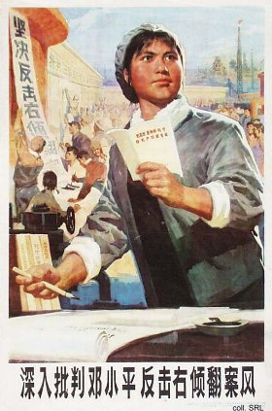 | 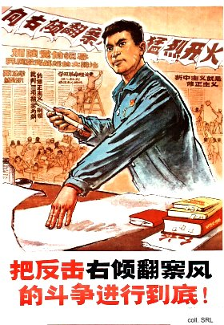
The immediate target of the Gang's campaign was Deng Xiaoping. He had been rehabilitated in 1973, and had closely cooperated with Zhou in his attempts to get China on the right track again, both politically and economically. In the process, many verdicts against former leaders and cadres at all levels had been reversed, ie, many were rehabilitated themselves and returned to their former positions. This rankled the Gang, who saw its power base threatened. They were convinced that Deng, and his supporters, were staging a comeback. The demonstrations in April were seen as proof of behind-the-scenes manipulation by Deng. As a "rightist deviationist who attempts to reverse correct verdicts", Deng was purged for a second time, only to return to power in 1977.
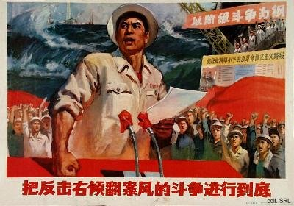
Source:
Kwok-sing Li (editor) & Mary Lok (translator), A Glossary of Political Terms of the People's Republic of China (Hong Kong: The Chinese University Press 1995)

