Criticize Lin Biao and Confucius (1974)

Already in 1973, Mao Zedong indicated that the criticism of Lin Biao and his followers should be combined with a thorough criticism of Confucius. In the following months, Mao's remarks gave rise to a spate of articles in the Chinese media praising the Legalists and Qin Shihuangdi, the first emperor of China. Obscure historical allegories, discussing events from the Warring States Period (475-221 BC) and the subsequent founding of the (first Chinese) Qin dynasty (221-207 BC), were used to support the Gang of Four (which sympathized with the Legalist philosophers).
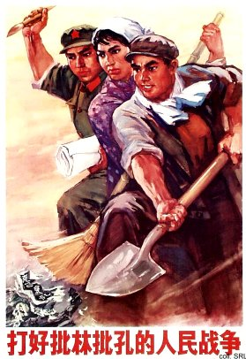 | 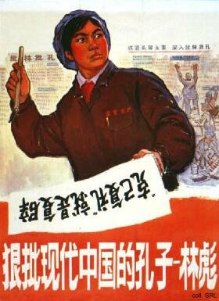
In the highly abstract and complicated debate that took place at the highest levels, Mao saw himself as a latter-day Qin Shihuangdi, who, as his example from antiquity did, opposed the modern-day Confucius: Zhou Enlai. To simplify the issues at stake: the Legalists, and Qin Shihuangdi, were seen as the progressive forces, opposing the Confucians who were considered reactionaries.
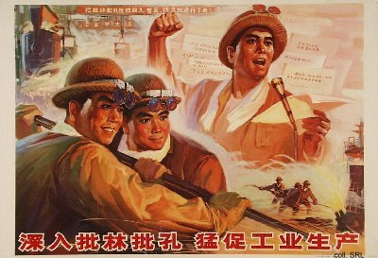
In January 1974, the struggle was made into a large-scale, national movement. The media continued to publish articles that ostensibly were critiques of Lin Biao and Confucius. In fact, they were innuendo attacks on Zhou Enlai and other rehabilitated veteran cadres, including Deng Xiaoping. Although the movement had been reviewed by Mao himself, the Central Committee regularly had to send out circulars to clarify matters. In the eyes of the Gang, the movement was not as far-reaching as intended; Jiang Qing in particular continued to rally for the "seizure of the modern-day Confucian".
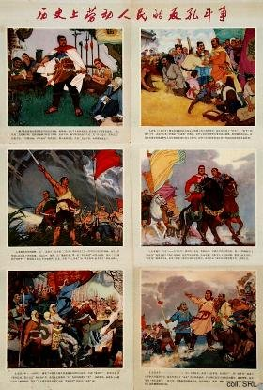 | 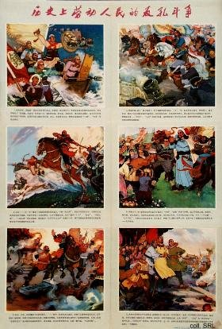
In December 1974-January 1975, Mao discussed the movement together with Gang-members and Zhou Enlai. Realizing that he had failed to oust Zhou, he turned his criticism on the Gang instead. Soon after, the movement was brought to a halt.
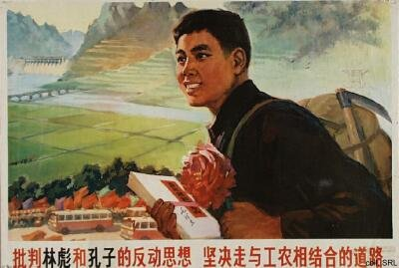

Source:
Kwok-sing Li (editor) & Mary Lok (translator), A Glossary of Political Terms of the People's Republic of China (Hong Kong: The Chinese University Press 1995)

