Cultural Revolution Campaigns

The Cultural Revolution (1966-1976) was a mass campaign of enormous dimensions. Aside from the general revolutionary high-tide that swept China, the period was marked by a large number of sub-campaigns. Indeed, whenever the situation called for a shift in orientation within the larger framework of the Cultural Revolution, this was engineered by setting in motion a new campaign. Factional struggles within the leadership also functioned as catalysts for campaigns. Often, these sub-campaigns came so hard and fast that propaganda posters had to serve as the main source of information for the people. With the country in complete chaos, these images which contained clear and unambiguous indications of what behavior and slogans were acceptable at that particular moment, were seen as more dependable than the media. This was in particular the case in those localities where the "excellent revolutionary" situation that prevailed—according to the media, that is—had become completely unintelligible to the innocent bystander.
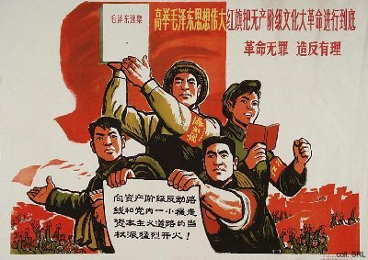
Locally produced posters are extremely interesting. Not only because they shed light on the local situation, but also from an artistic point of view. They are often striking in their simplicity of design and coloring, somewhat reminiscent of the block prints made in the war years. As such, they bear witness to the urgency of the times.
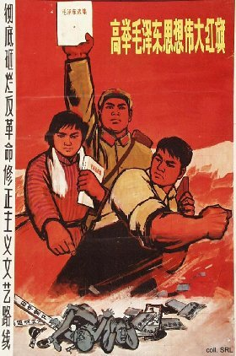 | 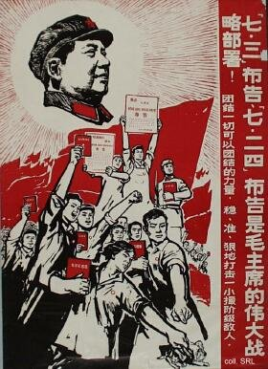

Criticize Lin Biao and Confucius (1974) | Criticize Rightist Deviationism (1976)
Criticize Shuihu zhuan Campaign (1975) | Monsters and Demons
Quotations from Chairman Mao | Revolutionary Committees (1967)
Revolutionary Networking (1966-1967) | Seven May Cadre Schools (1968)
Shanghai People's Commune (1967) | Study Theory (1975)
Up to the mountains, down to the villages (1968)
External Links: The Cultural Revolution (with some images)
The Great Proletarian Cultural Revolution, by Brain R. Train
The Red Guards

