Fifth National Census

On 1 November 2000, at 00:00 hours, work started for the Fifth National Census. More than ten million workers, including government officials, teachers and other volunteers, were mobilized for the project. In a period of ten days, these census workers visited the more than 350 million families in the country.
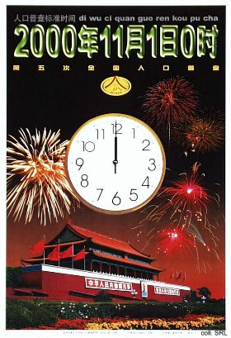 | 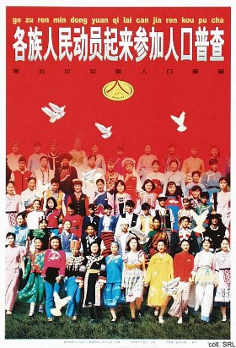
Some results of the census have already been made available. These include:
- Total population: 1.295 bn people (22% of total world population)
- Sex proportion: 116.9%
- The most populated administrative region: Henan Province (92.6 mn people)
- The least populated administrative region: Tibet (Xizang) Autonomous Region (2.6 mn people)
- The province with the fastest population increase since 1990: Guangdong Province (37.5% increase)
- Rural population: 64%. Urban population: 36%. The proportion of the urban population rose by almost 10% compared with the 1990 census
- University graduates per 100,000 people: 3.6 (1990: 1.4)
- Total number of military personnel: 2.5 mn
- Yearly average net increase of the population: 12.8 mn
- Average lifespan: Male--69 years; Female--73 years
- Percentage of those over 65 years: 6.96%
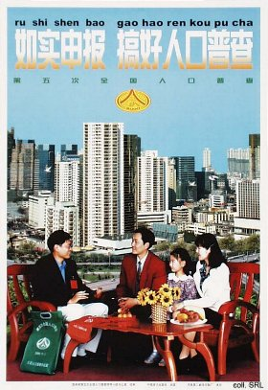 | 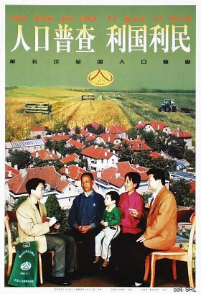
An interesting development in the posters that were intended to explain various aspects of the census is that they were sponsored by companies such as China Life (aka the People's Insurance Company of China, PICC). Although the State Council and other government organizations remained responsible for the overall publication process, it points to a trend where the party-state no longer necessarily functions as the main originator of such materials. The same applies to the posters published to support China's candidacy for the Olympic Games in 2008.

